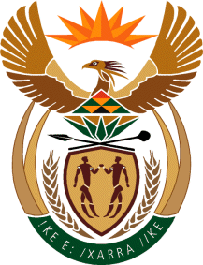
MINISTRY
SPORT AND RECREATION
REPUBLIC OF SOUTH AFRICA

Department of Sport and Recreation l Private Bag X896 l PRETORIA l 0001 l Regent Place l 66 Queen Street l Pretoria l 0001 l +27 (0)12 304 5158 l Fax: +27 (0)12 323 8426
Private Bag X9149 l Cape Town l 8000 l 2nd Floor Parliament Building l 120 Plain Street l CAPE TOWN l Tel: +27 21 469 5705 l Fax: +27 21 465 4402
www.srsa.gov.za
_____________________________________________________________________

NATIONAL ASSEMBLY

WRITTEN REPLY

QUESTION PAPER: No. 18 of 26 MAY 2017

DATE OF REPLY: 18 JUNE 2017

1477. Mr T W Mhlongo (DA) asked the Minister of Sport and Recreation:
Whether he is aware of any disputes that involve boxers not being paid by boxing promoters; if so, what are the (a) details of the current disputes, (b) names of (i) boxing promoters and (ii) boxers involved and (c) amounts owed in each case? NW1619E
______________________________________________________________________
The Minister of Sport and Recreation
REPLY:
There are no disputes that involve boxers not being paid by promoters, which have been brought to our attention, as the Department of Sport and Recreation South Africa. The last dispute that involved boxers not being paid their purse money by promoters was resolved by the end of December 2016. The promoters responsible were subjected to a disciplinary process. In that respect the last incident took place in April 2016 and there hasn’t been any such incident since then.

(a) N/A

(b) (i) and (ii) N/A

(c) N/A

