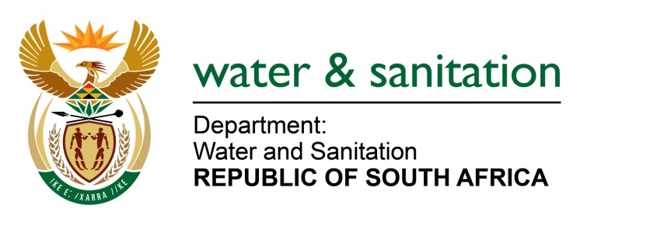

NATIONAL ASSEMBLY

FOR WRITTEN REPLY

QUESTION NO 1475

DATE OF PUBLICATION IN INTERNAL QUESTION PAPER: 05 MAY 2023
(INTERNAL QUESTION PAPER NO. 15)

1475. Mrs S M Mokgotho (EFF) to ask the Minister of Water and Sanitation:
What measures have been put in place to ensure that the community of Motlhabe village in North West receive adequate water supply as the taps that had been installed in their yards do not supply any water, and the specified community have lodged complaints with the Moses Kotane Local Municipality, but to no avail?
NW1707E
---00O00---

MINISTER OF WATER AND SANITATION

There has been sporadic water supply especially in the high lying areas such as the Rampodi and Thabeng sections in the Motlhabe Village due to increased demand, unauthorised household connections in the area and ongoing loadshedding.

In the short-term, the Moses Kotane Local Municipality (LM) has made funds available for drilling and equipping of additional boreholes to augment the current water supply. It is envisaged that this work will be completed by end of June 2023. The municipality is providing water through water tankers in the affected areas, whilst exploring medium to long term interventions.

In addition, the municipality has resolved that all unauthorised household connections should be formalised and metered to ensure sustainability of water supply as most of these connections are on the main pipeline supplying the village.

---00O00---

