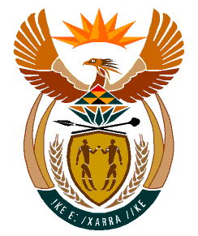

MINISTRY
HUMAN SETTLEMENTS
REPUBLIC OF SOUTH AFRICA

Private Bag X645, Pretoria, 0001. Tel: (012) 421 1309, Fax: (012) 341 8513
Private Bag X9029, Cape Town, 8000. Tel (021) 466 7603, Fax: (021) 466 3610

NATIONAL ASSEMBLY
QUESTION FOR WRITTEN REPLY

QUESTION NUMBER: PQ 1474 (NW1706E)

DATE OF PUBLICATION:

1474. Mrs S M Mokgotho (EFF) to ask the Minister of Human Settlements:
Whether she and/or her department have put any measures in place to assist the (a) provincial department of Human Settlements and (b) Moses Kotane Local Municipality to complete the unfinished houses in Motlhabe village in the North West that have stood incomplete since 2018; if not why not; if so, what time frame have been put in place to complete the construction of the specified houses?
NW1706E

REPLY

(a) & (b) The National Department of Human Settements has approved the Business Plan of the North West Department of Human Settlements for the 2023-2024 financial year, which amongst others, contains a list of incomplete projects such as Motlhabe 88.

The North West Department of Human Settlements had proposed an extension of scope to complete the 38 outstanding units on the afore-said housing project in 2022, however, the developer who was constructing the houses in Motlhabe did not agree to the approved funds granted per house due to the escalating costs of building materials, partcicularly the steel.

I am informed by the North West Department of Human Settlements that it is currently re-costing the incomplete project by taking it through the Supply Chain Management bid process within three months from the date hereof. The provincial Department anticipates to complete the outstanding units before the end of March 2024.

