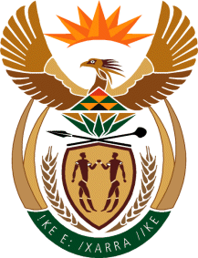
MINISTER IN THE PRESIDENCY: REPUBLIC OF SOUTH AFRICA
Tel: (012) 300 5200, Website: www.thepresidency.gov.za
NATIONAL ASSEMBLY
QUESTION FOR WRITTEN REPLY
QUESTION NUMBER: 1474

1474. Mr D J Maynier (DA) to ask the Minister in The Presidency:
Whether, in the light of his statement on 21 April 2016, (details furnished) any Ministers held talks with banks in order to find a lasting solution to the dispute with Oakbay Investments (Pty) Ltd; if not, why not; if so, in respect of each specified meeting with each specified bank, (a) what is the name of the bank, (b) on what date did the meeting take place, (c) what is the (i) name and (ii) designation of each Minister who was present, (d) what is the (i) name and (ii) designation of each bank employee who was present and (e) what was the outcome of each specified meeting? NW1643E
REPLY:
The Ministers who were mandated by the Cabinet as reflected on the Cabinet Statement have not yet reported back to the Cabinet.

