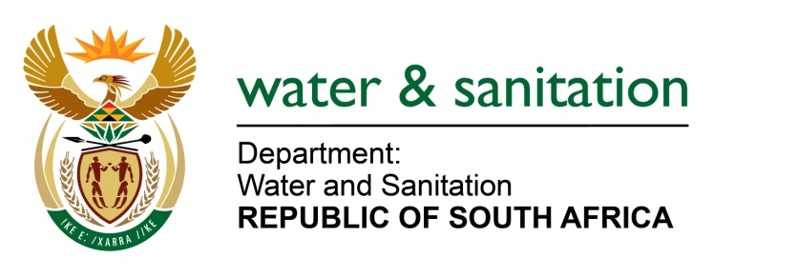

NATIONAL ASSEMBLY

FOR WRITTEN REPLY

QUESTION NO 1473

DATE OF PUBLICATION IN INTERNAL QUESTION PAPER: 05 MAY 2023
(INTERNAL QUESTION PAPER NO. 15)

1473. Ms N Tafeni (EFF) to ask the Minister of Water and Sanitation:
What form of assistance has his department provided to the residents of the Mbhashe Local Municipality in the Eastern Cape, who are currently facing water challenges? NW1705E
---00O00---
MINISTER OF WATER AND SANITATION
The Mbashe Local Municipality is supported by the Department of Water and Sanitation through the Water Services Infrastructure Grant (WSIG) and is implementing two water augmentation projects over a three-year period to address water supply challenges in the municipality. The table below provides details of the projects:

Project Name | Number of people to benefit | Budget | Implementation year
Equipping of boreholes in Mnquma and Mbhashe | 1 886 | R37 599 984 | 2023 - 2026
Drilling and testing of boreholes in Mbhashe, Mnquma and Great Kei | 9 830 | R21 881 418 | 2023 - 2026

The Xhora and Sundwana Bulk Water Schemes (BWS) currently being implemented by the Amathole District Municipality funded by DWS through the Regional Bulk Infrastructure Grant (RBIG). The Sundwana Bulk Water Scheme is at an advanced stage of planning which is expected to be concluded in 2023/2024; whilst commencement of construction is planned for 2024/2025. Construction on the Xhora BWS which includes a dam, Wastewater Treatment Works, reservoirs, and bulk pipelines has been completed. Construction for additional pipelines and reservoirs is at 61% and planned for completion in September 2023. The summarised details for both projects are indicated in the table below.

Project Name | Number of people to benefit | Budget | Implementation year | Status
Xhora BWS | 67 000 | R494, 082, 388.00 | 2009 - 2020 | Contracts 1-7 all 100% completed
 |  |  | 2020 - 2023 | Contract 8 is at 61% anticipated to complete in September 2023 with pipelines and reservoirs.
Sundwana WSS | 126 782 | R682 873 392 | 2024/25 | Advanced stage of planning

Areas affected by outages due to the electricity crisis are provided with water through water tankering. There are ongoing discussions between the municipality and Eskom for the exemption of water infrastructure from loadshedding.

---00O00---

