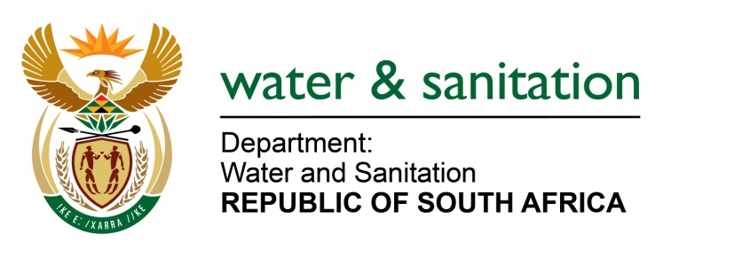

NATIONAL ASSEMBLY

FOR WRITTEN REPLY

QUESTION NO 1470

DATE OF PUBLICATION IN INTERNAL QUESTION PAPER: 22 APRIL 2022
(INTERNAL QUESTION PAPER NO. 14)

1470. Mr W Horn (DA) to ask the Minister of Water and Sanitation:
(a)(i) On what date was a full inspection in respect of the structural integrity of the bulk water supply pipeline between Welbedacht Dam and the Mangaung Metropolitan Municipality done and (ii) what were the findings and (b) what are the details of a proactive maintenance plan in respect of the pipeline in order to prevent and/or limit pipe bursts and emergency repairs?
NW1789E
---00O00---

MINISTER OF WATER AND SANITATION

- (i) The full Hydraulic assessment of the Pipeline from Welbedacht to Bloemfontein was conducted in February 2011 and a further assessment was conducted in October 2019 at one trajectory (Dehoek to Uitkyk) after a pipe failure occurred on that part of the pipeline.

(ii) The findings on the 2011 report indicated that:
- there were infrastructure components that required refurbishment,
- There were leaks on the pipeline which had to be addressed via the Bloem Water’s winter preventative maintenance shutdowns.

- Since the inspections were conducted, Bloem Water has done the following as part of a proactive maintenance plan:
- Established a Pipeline Reaction Team in 2015
- Reworked its Preventative Maintenance Strategy
- Established its inhouse pipeline manufacturing workshop which assists with pipeline components and quick turnaround time of maintenance work on the main pipeline

These measures have assisted Bloem Water to reduce real water losses on its strategic infrastructure to less than 13% for the past 8 financial years. Furthermore, three years has passed since the last pipe burst on this 48-year-old pipeline.

In addition, Bloem Water is currently implementing the construction project of a mitigating parallel line which is 33.7km long as phase 1. This pipeline will be in operation by July 2022 and will further preserve the status of reliable uninterrupted bulk water supply to the Mangaung Metro Municipality. The new pipeline will replace the problematic portion of the mainline which frequently experience pipe bursts. Phase 2 of the remaining 72km is currently under planning. This pipeline will replace the old line from Welbedacht Dam to Bloemfontein, once completed.

---00O00---

