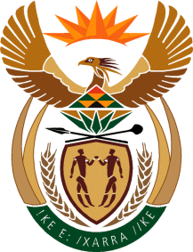

MINISTRY OF TOURISM
REPUBLIC OF SOUTH AFRICA

Private Bag X424, Pretoria, 0001, South Africa. Tel. (+27 12) 444 6780, Fax (+27 12) 444 7027
Private Bag X9154, Cape Town, 8000, South Africa. Tel. (+27 21) 469 5800, Fax: (+27 21) 465 3216

NATIONAL ASSEMBLY:

QUESTION FOR WRITTEN REPLY:
Question Number: 147
Date of Publication: 7 February 2019
NA IQP Number: 1
Date of reply: 20 February 2019

Mr W Horn (DA) to ask the Minister of Tourism:
With reference to the reply of the Minister of Public Service and Administration to question 3797 on 21 December 2018, what was the total expenditure incurred by his department relating to the travel privileges contained in the 2007 Ministerial Handbook of former (a)(i) Ministers and (ii) their spouses, (b)(i) Deputy Ministers and (ii) their spouses, (c) Ministers’ widows or widowers and (d) Deputy Ministers’ widows or widowers (i) in each of the past five financial years and (ii) since 1 April 2018? NW152E

Reply:

The Department of Tourism has not incurred any expenditure relating to any travel privileges of former (a)(i) Ministers and (ii) their spouses (b) (i) Deputy Ministers and (ii) their spouses (c) Ministers widows or widowers and (d) Deputy Ministers’ widows or widowers in each of the past five financial years and (ii) since 1 April 2018.

All expenditure relating to any travel privileges of former cabinet members is administrated by the Secretary to Parliament, according to the Ministerial Handbook, Chapter 10, on page 31 as approved by Cabinet on 7 February 2007.

