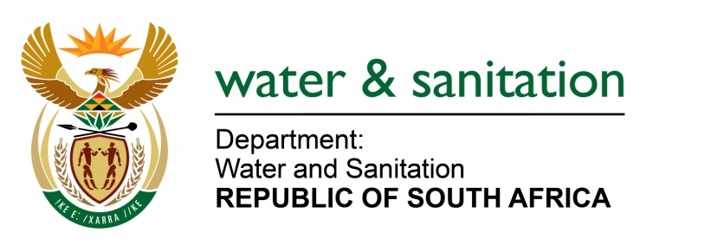

NATIONAL ASSEMBLY

FOR WRITTEN REPLY

QUESTION NO 1469

DATE OF PUBLICATION IN INTERNAL QUESTION PAPER: 22 APRIL 2022
(INTERNAL QUESTION PAPER NO. 14)

1469. Mr W Horn (DA) to ask the Minister of Water and Sanitation:
What total number of (a)(i) water engineers and (ii) structural engineers is provided for on the organogram of Bloem Water and (b) the specified positions for water and structural engineers were vacant on 28 February 2022?
NW1788E
---00O00---

MINISTER OF WATER AND SANITATION
(a) (i) The organogram makes provision for 73 water engineers and (ii) 34 structural engineers.

(b) Vacancies as of 28 February 2022

- Process controllers: 13
- Electrical Artisan: 1
- Mechanical Artisan: 1

---00O00---

