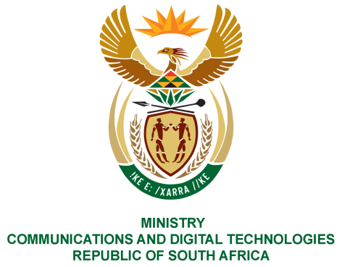
PARLIAMENT OF THE REPUBLIC OF SOUTH AFRICA
NATIONAL ASSEMBLY
WRITTEN REPLY

QUESTION NO: 1469
DATE OF PUBLICATION: 21 MAY 2021
QUESTION PAPER NO: 14

Mr M S Mabika (DA) to ask the Minister of Communications and Digital Technologies:

(1) Whether her department has concluded any work exchange and/or employment agreements with any entity of the Republic of Cuba from the 2010-11 financial year up to the 2020-21 financial year; if not, what is the position in this regard; if so, what (a) total number of Cuban nationals (i) have been employed in each of the specified financial years and/or (ii) are due to be employed in the 2021-23 Medium-Term Expenditure Framework period, (b) are the details of the work that each of the specified Cuban nationals was and/or will be employed to perform, (c) are the details of the specific skills sets that each of the specified Cuban nationals possessed and/or will possess that South African nationals did or will not possess and (d) are the details of the total cost of employing each of the specified Cuban nationals in each case;
(2) Whether her department took any steps to ensure that the specific skills set of the specified Cuban nationals were and/or will not be available in the Republic amongst South African citizens; if not, in each case, why not; if so, what are the relevant details of the (a) steps taken and (b) outcomes of the steps taken in this regard?
NW1673E

REPLY:

I have been advised by the Department as follows:

- No
- Not applicable

MS. STELLA NDABENI-ABRAHAMS, MP
MINISTER OF COMMUNICATIONS AND DIGITAL TECHNOLOGIES

