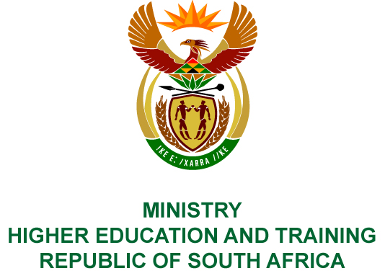
Private Bag X893, Pretoria, 0001, Tel (012) 312 5555, Fax (012) 323 5618
Private Bag X9192, Cape Town, 8000, Tel (021) 469 5150, Fax: (021) 465 7956
Memorandum from the Parliamentary Office
NATIONAL ASSEMBLY
FOR WRITTEN REPLY
QUESTION 1469
DATE OF PUBLICATION OF INTERNAL QUESTION PAPER: 11/05/2018
(INTERNAL QUESTION PAPER NO 15 OF 2018)
Ms N I Tarabella Marchesi (DA) to ask the Minister of Higher Education and Training:
(1) Whether, with reference to the reply of the President, Mr C M Ramaphosa, to the debate on the State of the Nation Address on 22 February 2018 to implement lifestyle audits, (a) she, (b) senior management service members in her department and/or (c) any of the heads of entities reporting to her have undergone a lifestyle audit in the past three financial years; if not, have any plans been put in place to perform such audits; if so, in each case, what are the details of the (i) date of the lifestyle audit, (ii) name of the person undergoing the audit, (iii) name of the auditing firm conducting the audit and (iv) outcome of the audit;
(2) whether she will furnish Ms N I Tarabella Marchesi with copies of the lifestyle audit reports?
NW1572E
REPLY:
- There are currently no plans in place to perform lifestyle audits. Should the need arise for such an audit; it will be performed within the applicable legislative framework.
- Not applicable.

