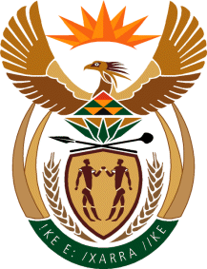

MINISTER IN THE PRESIDENCY: REPUBLIC OF SOUTH AFRICA
Private Bag X1000, Pretoria, 0001, Union Buildings, Government Avenue, PRETORIA
Tel: (012) 300 5200, Website: www.thepresidency.gov.za
NATIONAL ASSEMBLY – INTERNAL QUESTION PAPER
QUESTION FOR WRITTEN REPLY
QUESTION NUMBER: 1467

Mr A P van der Westhuizen (DA) to ask the Minister in The Presidency:

With reference to his reply to question 1161 on 9 May 2016, how many learners were registered as at 6 March 2016 to rewrite their National Senior Certificate examinations in October and November 2016 at each of the 31 sites where the National Youth Development Agency is offering the specified learners the opportunity to rewrite the specified exams?
NW1636E]
REPLY:

The closing date for learner registration was on 30 March 2016, all learners completed and signed the DOBE Examination Registration Form. The forms have been submitted to the relevant Department of Basic Education examinations offices based in provinces. The Department is working on ensuring that all learners are captured. It will issue the Preliminary Schedules in August/September 2016 to confirm that all learners are registered and their subjects are captured correctly.

