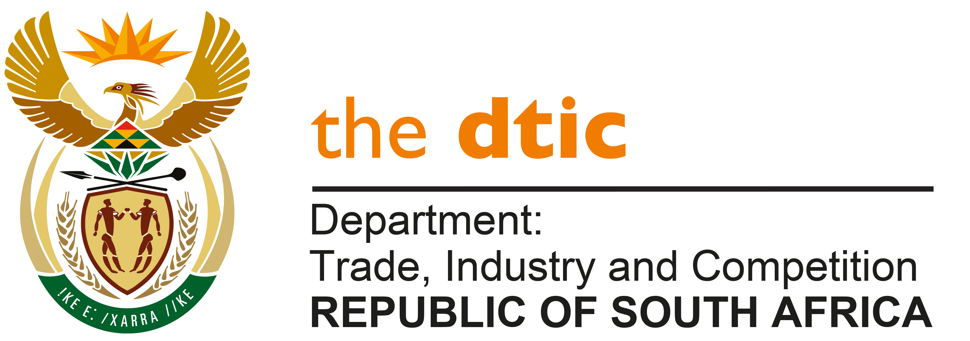

**THE NATIONAL ASSEMBLY**

**QUESTION FOR WRITTEN REPLY**

**QUESTION NO. 1464**

**DATE PUBLISHED: 22 APRIL 2022**

**Mr M J Cuthbert (DA) to ask the Minister of Trade, Industry and Competition:**

Whether he will furnish Mr M J Cuthbert with the final list of the beneficiaries of the R210 million COVID-19 Relief Fund; if not, why not; if so, what are the relevant details? NW1782E

**REPLY:**

I have been advised by the IDC and NEF as follows:

**Industrial Development Corporation (IDC)**

The IDC set aside a R800 million fund that gave financial support to companies providing essential supplies to address the COVID-19 Pandemic. This fund includes R300 million from the Department of Trade, Industry and Competition’s Manufacturing Competitiveness Enhancement Programme (MCEP). The table below provides details of the companies supported by the COVID Essential Supplies Fund.

| **Applicant Name** | **MCEP Finance** | **IDC Finance** | **Total Approved** | **Total Disbursed** |
| --- | --- | --- | --- | --- |
| Supra Healthcare | 30,000,000 | 100,000,000 | 130,000,000 | 130,000,000 |
| Alternative Living and Technical Solutions for Africa (Pty) Ltd | - | 27,000,000 | 27,000,000 | 25,639,250 |
| Amka Products (Pty) Ltd | 30,000,000 | 120,000,000 | 150,000,000 | 150,000,000 |
| Pharmapac (Pty) Ltd | 16,000,000 | 4,000,000 | 20,000,000 | 19,993,500 |
| Blend Tech (Pty) Ltd | 30,000,000 | 27,000,000 | 57,000,000 | 56,875,793 |
| Starrate (Pty) Ltd | - | 5,000,000 | 5,000,000 | 5,000,000 |
| Maba Africa (Pty) Ltd | 1,400,000 | 3,600,000 | 5,000,000 | 5,000,000 |
| Isondo Investments (Pty) Ltd | 1,200,000 | 300,000 | 1,500,000 | 1,500,000 |
| Crystal Pier 148 (Pty) Ltd | 12,000,000 | 14,000,000 | 26,000,000 | 10,728,407 |
| Starrate (Pty) Ltd |  | 13,000,000 | 13,000,000 | 13,000,000 |
| GQ Tissue Products (Pty) Ltd | 13,000,000 | 7,200,000 | 20,200,000 | 20,200,000 |
| **Grand Total** | **137,000,000** | **398,531,730** | **535,531,730** | **437,936,950** |

**National Empowerment Fund (NEF)**

The NEF set aside R200 million to provide financial assistance to companies that manufacture and supply essential products for Covid-19. A total of R211 million support was approved to the following beneficiaries:



**-END-**