National Assembly

Question No: 1463

Mr C H H Hunsinger (DA) to ask the Minister of Transport:
What (a) total number of licences are currently being processed by the SA Civil Aviation Authority, (b) total number of licence applications are for (i) renewal and (ii) new licences in respect of each different category of licences and (c) is the average duration and/or turnaround time from receiving applications to issuing them? NW1781E

Reply:

South African Civil Aviation Authority (SACAA)

(a) The South African Civil Aviation Authority (SACAA) processes an average of 168 licences per day and approximately 3500 aeroplane and helicopter licenses per month. (b) For the month of April 2022 alone, a total of 97 licenses have been issued of which for (i) renewals only seventy (70) are for aeroplanes and three (3) are for helicopters (ii) whilst for first issue applications twenty-three (23) were for aeroplanes and one (1) is for helicopters.
(c) During Covid-19, all license applications are received electronically and the average duration and/or turnaround time from receiving applications to issuing them is 7-10 working days provided that all regulatory requirements are met. These times will be revised to 5-7 working days as things return to normal.

RECOMMENDATION

- It is recommended that the EA approves the reply, should he concur with its content.

MR ZAKHELE THWALA
DEPUTY DIRECTOR-GENERAL: CIVIL AVIATION
DATE:

MR MTHUNZI MADIYA
ACTING DIRECTOR-GENERAL
DATE:

DECISION

Reply approved/amended.

MINISTER F.A. MBALULA, MP
MINISTER OF TRANSPORT
DATE:

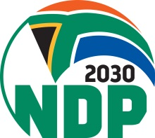
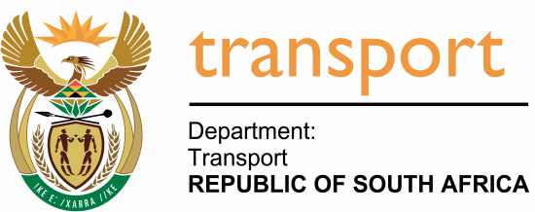
Date: 15/02/2018

Private Bag X 193, 159 Cnr. Struben and Bosman, Forum building, Pretoria, 0001, Tel; 012 309 3172, Fax: 012 328 5926

QUESTION 1463 (QUESTION PAPER NO 14, 22 APRIL 2022) FOR WRITTEN REPLY IN THE NATIONAL ASSEMBLY

Mr C H H Hunsinger (DA) to ask the Minister of Transport:
What (a) total number of licences are currently being processed by the SA Civil Aviation Authority, (b) total number of licence applications are for (i) renewal and (ii) new licences in respect of each different category of licences and (c) is the average duration and/or turnaround time from receiving applications to issuing them? NW1781E

Reply:

South African Civil Aviation Authority (SACAA)

- The South African Civil Aviation Authority (SACAA) processes an average of 168 licences per day and approximately 3500 aeroplane and helicopter licenses per month. (b) For the month of April 2022 alone, a total of 97 licenses have been issued of which for (i) renewals only seventy (70) are for aeroplanes and three (3) are for helicopters (ii) whilst for first issue applications twenty-three (23) were for aeroplanes and one (1) is for helicopters. (c) During Covid-19, all license applications are received electronically and the average duration and/or turnaround time from receiving applications to issuing them is 7-10 working days provided that all regulatory requirements are met. These times will be revised to 5-7 working days as things return to normal.

MINISTER F.A. MBALULA, MP
MINISTER OF TRANSPORT

