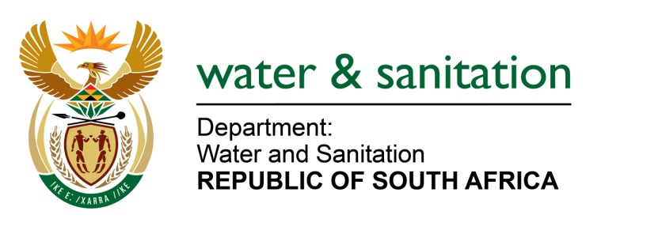

NATIONAL ASSEMBLY

FOR WRITTEN REPLY

QUESTION NO 1461

DATE OF PUBLICATION IN INTERNAL QUESTION PAPER: 05 MAY 2023
(INTERNAL QUESTION PAPER NO. 15)

1461. Ms P Marais (EFF) to ask the Minister of Water and Sanitation:
Considering that the community of Pabalelo in the Northern Cape has had a pit latrine crisis for decades with no manifestation of promises from the Government on eradicating the bucket system in the specified community, (a) what are the reasons that the eradication of the bucket system had not been a reality in Pabalelo to date, (b) what steps will he take to ensure that promises to eradicate the bucket system will become a reality and (c) by what date will the bucket system in Pabalelo eventually be done away with? NW1689E
---00O00---

MINISTER OF WATER AND SANITATION
- The Department through the Bucket Eradication Programme implemented 5 projects in David Kruiper Local Municipality from 2013 to 2017. These include
Area | No. of toilets eradicated
Pabalelo | 596
Kalksloot | 120
Rosedale | 1771
Louisvale | 600
Dakota Weg | 306
Total | 3393
- Several areas or settlements are being formalised which still use the bucket toilet system and are considered “new” buckets. These cases occurred after the implementation of interventions aimed at reaching the target set in 2015, hence they have not yet been addressed.

- The Department has noted the moving target however, an implementation plan will be developed to attend to the remaining bucket toilets including the required bulk services necessary for planning and budgeting purposes.
---00O00---

