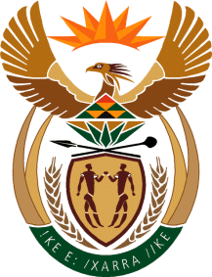

MINISTRY OF TOURISM
REPUBLIC OF SOUTH AFRICA

Private Bag X424, Pretoria, 0001, South Africa. Tel. (+27 12) 444 6780, Fax (+27 12) 444 7027
Private Bag X9154, Cape Town, 8000, South Africa. Tel. (+27 21) 469 5800, Fax: (+27 21) 465 3216

NATIONAL ASSEMBLY:

QUESTION FOR WRITTEN REPLY:
Question Number: 1456
Date of Publication: 10 July2020
NA IQP Number: 25
Date of reply: 25 August 2020

Mr I M Groenewald (FF Plus) to ask the Minister of Tourism:

(1) Apart from the R200 milion relief fund for the tourism industry, what other measures, programmes and/or initiatives are being put in place to assist the tourism industry;

(2) which of these measures, programmes and/or initiatives do not have broad-based black economic empowerment accreditation requirements in order to qualify;

(3) whether she will make a statement on the matter?

NW1827E
REPLY:

- Apart from the Tourism Relief Fund what other measures, programmes and/or initiatives are being put in place to assist the tourism industry.
Apart from the Tourism Relief Fund, the Department has established a Tourist Guides ReliefFund for which a R30 million budget has been set aside to provide relief to freelance tourist guides.
The tourism sector, like all other industries and sector of the economy alsohas access to other forms of Covid-19 financial relief measures such Tax Relief fromSouth African Revenue Services (SARS), Temporary Employee Relief Scheme (TERS) or Unemployment Insurance Fund (UIF) Covid-19Relief Benefit from the Department of Employment and Labour; and the National Treasury’s R200 billon Credit Guarantee Scheme.
- Which of these measures, programmes and/or initiatives do not have broad-based black economic empowerment accreditation requirements in order to qualify.
N/A

- Whether the Minister will make a statement on the matter.
The Minister and/or departmenthas made public statements in relation to the relief measures that are provided by the department.

