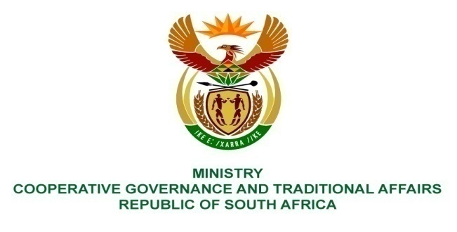
________________________________________________________________________________________

FOR WRITTEN REPLY
NATIONAL ASSEMBLY
PARLIAMENTARY QUESTION 1448

Dr. G A Grootboom (DA) to ask the Minister of Cooperative Governance and Traditional Affairs:
- Who is building the generator for the Windsor pump station in the Ekurhuleni Metropolitan Municipality, (b) what is the cost of building the generator, (c) when will the generator be delivered and (d) when will it be installed?

Reply:
According to the information received from Ekurhuleni Metropolitan Municipality:
(a). At the moment, there is no one building a generator for the Windsor pump station, however, a feasibility study for extension of the pump station has been completed, installation of one pump and a generator.
(b). Total cost is estimated at R 4, 500, 000
(c). April 2018/2019 metro financial year due to budget allocation, should savings be available in 2017/ 2018 financial year then the project will be brought forward.
(d). End of April 2019

