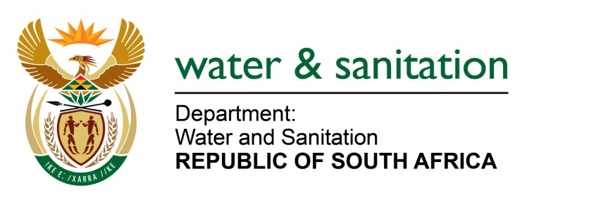

NATIONAL ASSEMBLY

FOR WRITTEN REPLY

QUESTION NO 1447

DATE OF PUBLICATION IN INTERNAL QUESTION PAPER: 26 MAY 2017
(INTERNAL QUESTION PAPER NO. 18)

1447. Mr M Waters (DA) to ask the Minister of Water and Sanitation:
(1) When did Rand Water (a) start with maintenance work on their G28 concrete pipeline and (b) inform the Ekurhuleni Metropolitan Municipality about the pending work;
(2) whether she will furnish Mr M Waters with a copy of the letter to this effect; if not, why not; if so, by what date? NW1589E
---00O00---
REPLY:
(1)(a) Rand Water conducted a conditional assessment on the G28 and the entire network from the 8 to the 14 May 2017.
(1)(b) Yes, Rand Water did inform Ekurhuleni Metropolitan Municipality of the condition assessment to be carried out at G28 pipeline.

(2) Refer to Annexure A for the copy of the email that informed Ekurhuleni Metropolitan Municipality of the condition assessment to be carried out at G28 pipeline.
---00O00---

