FOR WRITTEN REPLY QUESTION 1446

NATIONAL ASSEMBLY
36/1/4/1(201800135)

DATE OF PUBLICATION IN INTERNAL QUECTION PAPER: 11 MAY 2018 (INTERNAL QUESTION PAPER NO 15-2018}

1446. Mrs A gl Dreyer (DA) to ask the Minister of Police:

What number of (a) vehicl06 are there for detectives at the Tembisa South Pollca Station, (b) these vehicles have mileage of (I) 1 — 100 O00kms, (ii) 100 001 200 000kms, (iii) 200 001 - 300 000kms and (lv) over 300 000kms and (c) days in 2017 were each of the speclfled vehicles out of working order?
NW1548E

REPLY:
(»()b)(‹)(i‹)(‹'i)(lv)()

 | (b)(I) 1•10g BtoXms |  | (h)(IT) 148 001-  200 000kms |  | (sj‹iiil zoo Vol-  800 000kme |  | tb)(lv) ov•r zoo oe0xms
 | (e) Number of  vefilcles | (o) daya out of  working orbaf | (8)  Numbgr of vahlcles | \c) days out of  wo#‹Irfg otdar | (a) Number of  vehlclas | (c) day6 oJt of  working ofdar | (a) Nurrjbat  of yehIdes | (c\ days out of  working order
 | BTX 916 B  BTL 841 B BTM 4g8 B BVC 887 B | 1 day  1 day  1 day J day | BgX 04b B  BFW 84g B BGW 680 B B9W BPO B | 4 day  1 day  4 dgy  1 day | • | - | - | -
 |  |  | B8W 847 B  BSS 488 | 1 dam  1 day
 |  |  | BTB g28 B | 1 day
 |  |  | 1g vahiolas

Reply to question 1446 recommended/

éTl L C
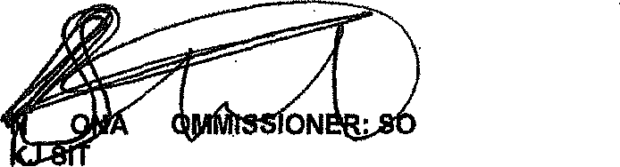
OLE (SOEG) 201f •05- t 8
GENERAL UTH AFRICAN POLICE SERVICE

Data:

Reply to question 1446 approvad/‹u›t-aggro

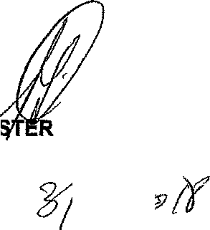
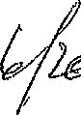
MINI
OF POLICE
BH CELE, M°

