MINISTRY
PUBLIC WORKS AND INFRASTRUCTURE
REPUBLIC OF SOUTH AFRICA

Department of Public Works l Central Government Offices l 256 Madiba Street l Pretoria l Contact: +27 (0)12 406 2034 l +27 (0)12 406 1224
Private Bag X9155 l CAPE TOWN, 8001 l RSA 4th Floor Parliament Building l 120 Plein Street l CAPE TOWN l Tel: +27 21 468 6900 Fax: +27 21 462 4592
www.publicworks.gov.za

NATIONAL ASSEMBLY

WRITTEN REPLY

QUESTION NUMBER: 144 [NW1102E]

INTERNAL QUESTION PAPER NO.: 03 (of 2019)
DATE OF PUBLICATION: 05 JULY 2019
DATE OF REPLY: 22 JULY 2019

144. Mr M N Nxumalo (IFP) asked the Minister of Public Works and Infrastructure:
(1) Whether her department has an appropriate time frame in place with regard to the completion of renovations that are currently undertaken at the Durban High Court and which have been interfering with court proceedings; if not, why not; if so, what are the relevant details;

(2) Whether she has found that her department is taking appropriate steps to ensure that the court proceedings are not affected; if not, why not; if so, what are the relevant details of the steps? NW1102E

______________________________________________________________________________

REPLY

The Minister of Public Works & Infrastructure:

(1) Currently there are no renovations taking place at the Durban High Court. The Department is in planning for renovations and upgrades to the Durban High Court. The process is currently at the procurement stage (preparing to invite tenders from interested contractors). However, there is construction activity happening in the adjacent Department of Labour Masonic Grove building (separate stand-alone building across Dullah Omar Grove, as shown below.
The Department of Labour Masonic Grove building renovations are scheduled to be completed in May 2020.

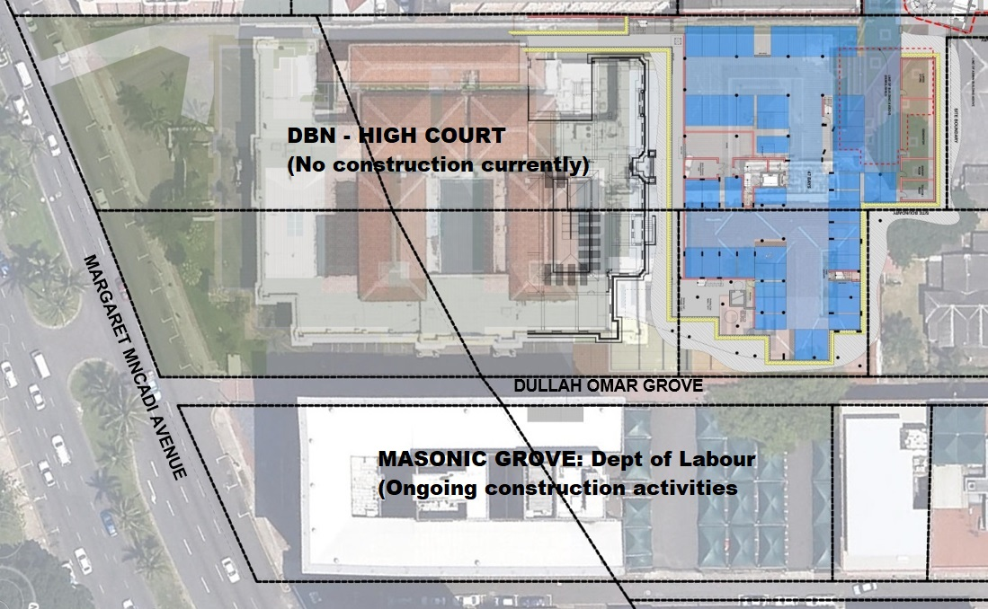

(2) The Department has appointed the Independent Development Trust (IDT) as an implementing agent to oversee the refurbishment of the Department of Labour Masonic Grove building. In ensuring that there were no disruptions in the proceedings of High Court operations the Department of Public Works instructed the IDT to conduct a meeting with the Durban High Court management to sensitise them about the planned project and agree on a workable noise management strategy.

The meeting involving IDT Programme Manager, a representative of the Department of Justice, as well as the contractor was held at the Durban High Court 1st Floor Boardroom on the 11th September 2018. The contractor explained that most of the noisy works will only be carried out over weekends. The contractor would however do the less noisy work may during working hours.

It was expected that should there be any noise disruption the Durban High Court would notify the contractor, IDT programme manager or the Department of Public Works.

As a result of this Parliamentary Question, the Department of Public Works and Infrastructure will set about to investigate the noise matter, although it has not been formally reported. But, the contractor and IDT have since been notified of the noise issue and they committed to reduce any noisy activity that might create disruptions during court proceedings at Durban High Court.

In order to address a larger problem of the poor state of court buildings I will be convening a meeting with the regional court managers are other role players to assess the state of the courts and ensure that repair and maintenance plans are put in place and implemented at soon as possible. It is a matter of concern that many courts are inaccessible due to the state of the buildings they are housed in. In many cases one finds lifts and air-conditioning systems that in a state of disrepair. This has a great impact on the ability of the court officials to execute their duties. I will invite the Minister of Justice and Correctional Services to this meeting.

I will make the report on the assessment of the courts available to the public and also present it to the Portfolio Committee in Parliament. With regard to the Durban High Court, I will engage with the Department’s management to ensure that the undertaking not to disturb the court proceedings is observed.

