National Assembly

Question Number: 1429

1429. Mr C H H Hunsinger (DA) to ask the Minister of Transport:

(a) Who is the concessionaire of the Huguenot Tunnel in the Western Cape, (b) when were they appointed, (c) how were they appointed, (d) what criteria were used to appoint them, (e) when did this concessionaire start, (f) when will it be terminated (g) what are the terms and conditions of this concessionaire and (h) what financial costs and implications exist for Sanral or any other entity? NW1571E
REPLY
(a) The Huguenot Tunnel is not a concession contract, but a state-owned toll road, as it is funded and maintained by SANRAL. The toll operations and tunnel management are outsourced to Tolcon Group, the Operator. SMEC Consulting Engineers are the appointed professional service providers; and are responsible for overseeing the operations and maintenance of the Huguenot Toll Plaza and Tunnel.
(b) Tolcon was appointed on 27 November 2014 and the Operations and Maintenance contract officially commenced on 01 February 2015.
(c) Tolcon and SMEC Consulting Engineers were appointed after an open tender process.
(d) The tender provided for a functionality requirement to be met as a minimum. This was calculated on the following basis:
THE QUALITY CRITERIA AND MAXIMUM SCORE IN RESPECT OF EACH OF THE CRITERIA ARE AS FOLLOWS:  FORM | DESCRIPTION OF QUALITY CRITERIA AND SUB-CRITERIA | MAXIMUM NUMBER OF TENDER EVALUATION POINTS
B1 | Schedule of Work Experience in comparable projects | 20
B3 | Proposed Personnel for Key staff | 15
B4 | Continuing professional development of the Key staff | 5
B5  (Items 1,4,5, & 6) | Organisational structure, Logistics, support structures and managerial ability appropriate to the size and nature of the work | 10
B5  (Item 2) | Financial control structures | 10
B5  (Item 3) | Financial information | 5
B5  (Item 7) | Maintenance proficiency | 15
B7 | Toll Systems Replacement: Methodology, Approach & Technical Compliance | 15
B8 | Toll Manning Configuration | 5
Total evaluation points for quality (MS) |  | 100

The minimum number of evaluation points for quality (WQ) was 75.

All compliant tenders who met the threshold moved on to the second stage of the tender evaluation which was Price and Preference (90/10).
Scoring preference:
Up to 100 minus W1 tender evaluation points will be awarded to tenderers who submit responsive tenders and who are found to be eligible for the preference claimed. Points are based on a tenderer’s scorecard measured in terms of the Broad-Based Black Economic Empowerment Act (B-BBEE, Act 53 of 2003) and the Regulations (2009) to the Preferential Procurement Policy Framework Act (PPPFA, Act 5 of 2000).
Points awarded were allocated according to a tenderer’s B-BBEE status level of contributor and summarised in the table below:

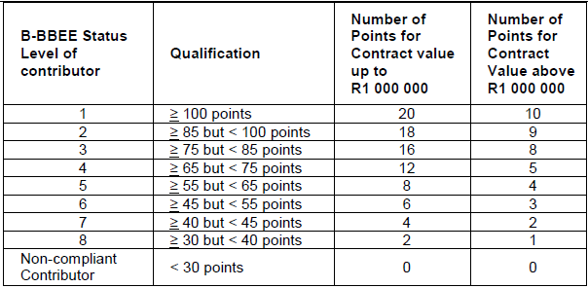

The score for price was calculated out of the 90 points using the formula:
A = (1 – (P – Pm)/Pm)

Pm is the comparative offer of the most favourable comparative offer
P is the comparative offer of the tender offer under consideration
The points for Price was then added to the Preference Point for a total point out of 100. The tender is awarded to the highest point scorer.

(e) It should be noted that this is not a concession contract, but the current Operations and Maintenance contract started on 01 February 2015.
(f) The contract was awarded for a 3 year period, with an option to extend for a further 2 years.
(g) Not applicable
(h) The Huguenot Toll Plaza and Tunnel is part of the SANRAL Toll Portfolio. Details of bonds issued in the capital markets to fund the Portfolio with each bonds corresponding coupon rate is disclosed in the SANRAL financial statements.

