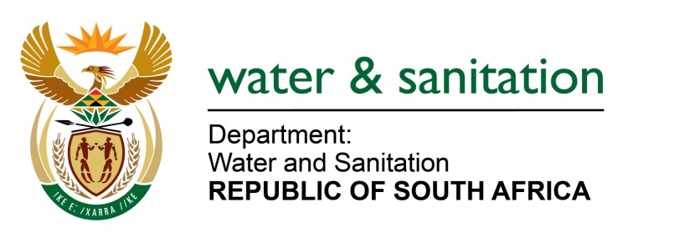

NATIONAL ASSEMBLY

FOR WRITTEN REPLY

QUESTION NO 1426

DATE OF PUBLICATION IN INTERNAL QUESTION PAPER: 17 APRIL 2015
(INTERNAL QUESTION PAPER NO. 10)
1426. Mrs D Robinson (DA) to ask the Minister of Water and Sanitation:
Does her department have a Regulatory Burden Reduction strategy in place; if not, why not; if so, what are the relevant details of the strategy? NW1639E
---00O00---
REPLY:
Yes. Cabinet has recently approved the Socio Economic Impact Assessment System (SEIAS) which is effective from 1 June 2015. The SEIAS requires that government departments must, before developing any policy, regulations and legislation, ensure that they take steps to minimize the unintended consequences of such policy, regulations and legislation, including unnecessary costs of implementation and compliance. The SEIAS further requires government departments to anticipate implementation risks and develop measures to mitigate such risks.
---00O00---

