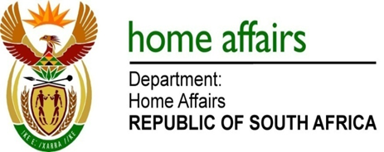

NATIONAL ASSEMBLY

QUESTION FOR WRITTEN REPLY

QUESTION NO. 1425

DATE OF PUBLICATION: FRIDAY, 11 MAY 2018

INTERNAL QUESTION PAPER 15 OF 2018

1425. Mr D J Maynier (DA) to ask the Minister of Home Affairs:

Whether, with reference to the Minister of Finance’s reply to question 43 on 2 May 2018, he intends to repay some and/or all of the expenses incurred by the National Treasury for a certain person’s (name furnished) official travel since 1 April 2017; if not, what is the position in this regard; if so, what are the relevant details? NW1527E

REPLY:

Ministers’ spouses are allowed to travel with their partners abroad on official trips as per Ministerial Handbook. The policy applies to all executive members and there is no provision currently that talks of repayment.

