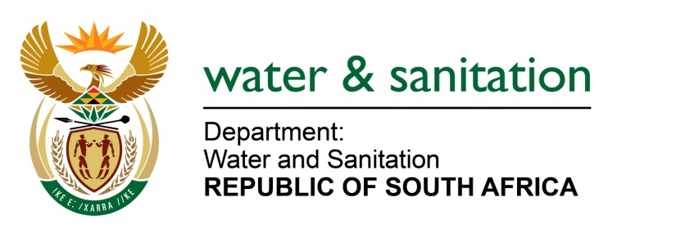

NATIONAL ASSEMBLY

FOR WRITTEN REPLY

QUESTION NO 1422

DATE OF PUBLICATION IN INTERNAL QUESTION PAPER: 13 MAY 2016
(INTERNAL QUESTION PAPER NO. 14)

1422. Dr M J Figg (DA) to ask the Minister of Water and Sanitation:
What (a) progress has been made to date on the Nooitgedacht Low Level Scheme in the Nelson Mandela Bay Metropolitan Municipality in the Eastern Cape, (b) amount has been spent to date and (c) is the expected date of completion of the specified scheme? NW1570E
---00O00---
REPLY:

- Phase 1 for the installation of the ±45 km pipe work and associated works was completed at a cost of R570 million. Phase 2 commenced in December 2014.

- Phase 2 expenditure for the 2014/15 Municipal financial year was R59.6 million. It is anticipated that the expenditure for 2015/16 (30 June 2016) will be R82 million. A further R40 million has been budgeted for the completion of Phase 2 during the 2016/17 financial year.

- Phase 2 is scheduled for completion by March 2017 with Phase 3 in December 2018.
---00O00---

