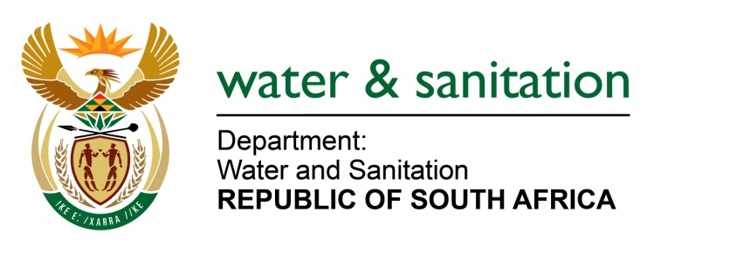

NATIONAL ASSEMBLY

FOR WRITTEN REPLY

QUESTION NO 1421

DATE OF PUBLICATION IN INTERNAL QUESTION PAPER: 13 MAY 2016
(INTERNAL QUESTION PAPER NO. 14)

1421. Mr L J Basson (DA) to ask the Minister of Water and Sanitation:
With reference to the report delivered by her department to the Portfolio Committee on Water and Sanitation on 7 April 2016, where it was reported that the unsuccessful roll-over of R1, 601 billion from the 2014-15 financial year resulted in the rescheduling of a number of infrastructure projects, what are the (a) names (b) amounts (c) delays and (d) increases in costs of each of the specified projects? NW1569E
---00O00---
REPLY:

Refer to Annexure A for the names, amounts, delays and cost of the specified projects affected by non-approval of rollover from 2014/15.
Although the non-approval of the rollover had a negative impact on the cash flow for projects, my Department had to reprioritise within projects, whereby funds were shifted from slow moving projects, to those projects affected by non-approval of the rollover to avoid delays and cost escalations. The available budget was spent in full for the 2015/16 financial year.
---00O00---

