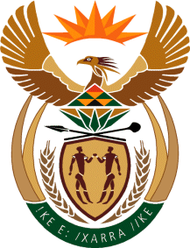

MINISTRY: COMMUNICATIONS
REPUBLIC OF SOUTH AFRICA
Private Bag X 745, Pretoria, 0001, Tel: +27 12 473 0164 Fax: +27 12 473 0585
Tshedimosetso House,1035 Francis Baard Street, Tshedimosetso House, Pretoria, 1000

NATIONAL ASSEMBLY
QUESTION FOR WRITTEN REPLY
QUESTION NUMBER: 142
DATE OF PUBLICATION: 9 FEBRUARY 2017
Mr M W Rabotapi (DA) to ask the Minister of Communications:
Whether the research study that the Media Development and Diversity Agency commissioned in the 2015-16 financial year in Programme 2 is publicly available; if not (a) by what date and (b) where will she make the report available for public consumption, if so, (a) what are the recommendations contained in the report, (b) by what date will each recommendation be implemented and (c) what are the further relevant details regarding each recommendation? NW147E
REPLY: MINISTER OF COMMUNICATIONS

No, the National Communication Radio Forum research study on sustainability of community broadcast, which was commissioned in 2015/2016, is not yet publicly available as it has not yet been completed.
(a) It will be made available in 2018.
(b) The report will be made available on the MDDA website.
(a) Not Applicable
(b) Not Applicable
(c) Not Applicable

MR NN MUNZHELELE
DIRECTOR GENERAL [ACTING]
DEPARTMENT OF COMMUNICATIONS
DATE:

MS AF MUTHAMBI (MP)
MINISTER OF COMMUNICATIONS
DATE

