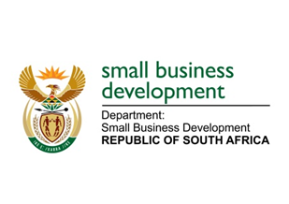
NATIONAL ASSEMBLY
QUESTION FOR WRITTEN REPLY
DUE TO PARLIAMENT: FRIDAY, 28 MAY 2021

“1418. Mrs E R Wilson (DA) to ask the Minister of Small Business Development:
(1) Whether (a) her department and/or (b) entities reporting to her funded/contributed to the supply and/or installation of the production line for the manufacture of protective masks at a certain factory (name and details furnished); if so, (a) to what value and (b) on what date;
(2) whether her department has awarded any tenders for the supply of (a) masks or (b) shoes to the specified factory; if not, what is the position in this regard; if so, (i) what is the (aa) value, (bb) extent and (cc) number of each tender and (ii) on what date was each tender awarded?” NW1615E
_________________________________________________________________________________
REPLY:
(1)(a)&(b) The Department of Small Business Development (DSBD), nor its agencies – the Small Enterprise Development Agency (Seda) and the Small Enterprise Finance Agencies (sefa), have not funded /contributed to the supply and/or installation of the production line for the manufacture of protective masks from the Dick Whittington Shoe Factory in Pietermaritzburg.

(2) The Department has not awarded any tender to any factory for the supply of masks. The masks procured in March 2020 were procured through a quotation process.

_______________________________________________________________________________
RESPONSE RECOMMENDED BY:

_______________________
MR LINDOKUHLE MKHUMANE
ACTING DIRECTOR GENERAL: DEPARTMENT OF SMALL BUSINESS DEVELOPMENT
DATE:

______________________________________________________________________________
RESPONSE RECOMMENDED BY:

________________________
MS ROSEMARY CAPA, MP
DEPUTY MINISTER OF SMALL BUSINESS DEVELOPMENT
DATE:
_______________________________________________________________________________
RESPONSE APPROVED BY:

_________________________
MS KHUMBUDZO NTSHAVHENI, MP
MINISTER OF SMALL BUSINESS DEVELOPMENT
DATE:

