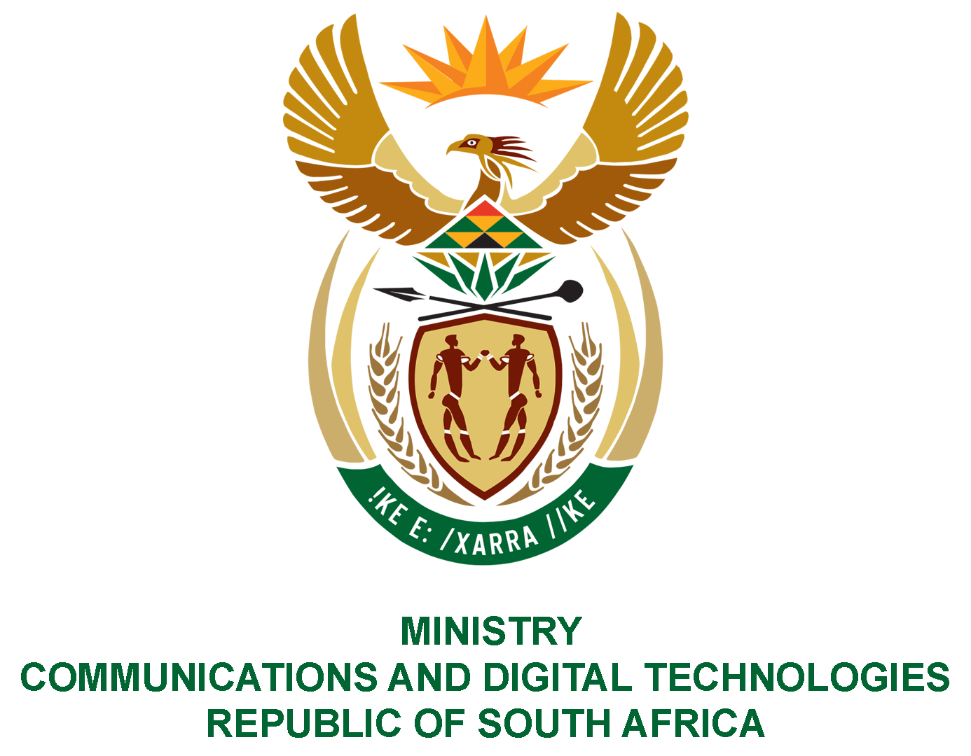

PARLIAMENT OF THE REPUBLIC OF SOUTH AFRICA

NATIONAL ASSEMBLY

WRITTEN REPLY

QUESTION: 1417

DATE OF PUBLICATION: 22 APRIL 2022
QUESTION PAPER NO: 14

Ms Z Majozi (IFP) to ask the Minister of Communications and Digital Technologies:

With reference to the final switch-off date for analogue that was extended to 30 June 2022, what is the detailed status update on the (a) current progress in this regard and (b) progress of (i) applications and (ii) registrations for the government-subsidised set-top boxes?
NW1734E
REPLY:

I have been advised by the Department as follows:

- As per the court judgement, the department needs to conclude 100% installations by 30 June 2022, for those who have registered before 31 October 2021. The numbers that were due for installations by 30 June 2022 as per Gauteng High Court judgement were completed by the set date except for 106, 571 in KZN and Eastern Cape due to the impact of the floods.
- Applications and approved registrations from 1 November 2021 to 31 March 2022 were 260, 868. Applications received between 1 April 2022 and 30 June 2022 were only 49, 385
(i) At the time of publication of the question, the Gauteng High Court had extended the date for analogue switch off to 30 June 2022.
(ii) There is no way of knowing the number of households watching TV through analogue TV sets and it is for that reason that government called for those watching TV through analogue and qualifying for government assistance to apply for assistance. In addition, Digital television cannot only be watched through STBs but digital television sets which were already sold in South Africa since 2012. Between 2016 to date, more than 2.6 million Digital TV sets have been sold in South Africa and can be deemed majority TV sets in households. Furthermore, government has taken measures to ensure South Africans do not unknowingly buy Analogue TV sets in the market.

