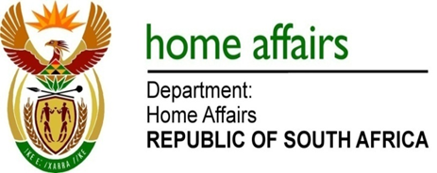

NATIONAL ASSEMBLY

QUESTION FOR WRITTEN REPLY

QUESTION NO. 1416

DATE OF PUBLICATION: FRIDAY, 11 MAY 2018

INTERNAL QUESTION PAPER 15 OF 2018

1416. Mr A M Figlan (DA) to ask the Minister of Home Affairs:

What are the details of all steps taken by his department to integrate his department’s information technology with those of other Government departments in pursuit of improving e-Government as per the targets set out in the National Development Plan? NW1518E

REPLY:

The Department is in process of modernising all core systems in order to enable efficient and secured service delivery to citizens. Development of systems is aligned to the Government Wide Enterprise Architecture (GWEA) as prescribed through Department of Public Service and Administration (DPSA); a standard that enables ongoing and future integration of government systems.

To date the Department has enabled online verification of clients by Government Departments, Banks, Insurance institutions and other private companies that have opted to participate. Online verification is available through direct integration with the Department’s database, and also for the law enforcements agencies that access through the Integrated Justice System (IJS) hub. The Department is in process of upgrading the current host of online verification which is the Home Affairs National Identification System (HANIS) to an Automated Biometrics Identification System (ABIS). ABIS will provide more powerful search and retrieval capability and reduce the turnaround times of results as required by SA Police Service and other law enforcement agencies.

