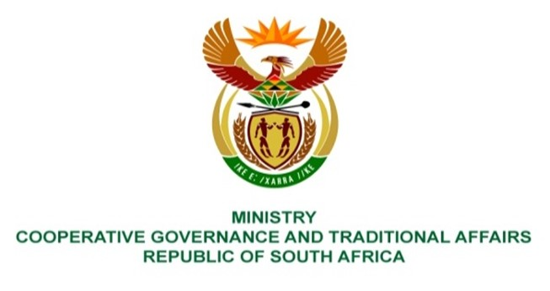

NATIONAL ASSEMBLY
QUESTIONS FOR WRITTEN REPLY

QUESTION NUMBER: 2021/1411
DATE OF PUBLICATION: 21 MAY 2021

QUESTION:

1411. Mr N P Masipa (DA) to ask the Minister of Cooperative Governance and Traditional Affairs:
(1) What is the (a) extent of the commonage land in Mpumalanga and (b) current usage of the commonage land;
(2) whether the commonage land has water rights to allow farming to take place; if not, what steps will her department take to ensure that there are water rights; if so, what are the relevant details;
(3) whether there are farming activities taking place on the commonage land; if not, why not; if so, what farming activities are taking place on the pieces of land;
(4) (a) whether she will furnish Mr N P Masipa with the relevant information regarding land that has been invaded and (b) the action(s) that were taken regarding the situation; if not, why not; if so, on what date? NW1608E

REPLY:
My department requested the Provincial department to provide a details in relation to question raised by the honourable member. The reply will be updated with the information as it becomes available.

BACKGROUND INFORMATION:

