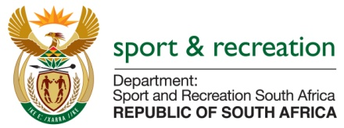

PARLIMENTARY QUESTION FOR THE MINISTER

QUESTION NUMBER 1410

1410. Mr S C Motau (DA) to ask the Minister of Sport and Recreation:
Whether (a) his department and (b) all entities reporting to him are running development programmes for (i) small businesses and (ii) co-operatives; if not, why not; if so, in each case, (aa) what are the relevant details, (bb) what amount has been budgeted and (cc) how many jobs will be created through the specified development programmes in the 2016-17 financial year? NW1558E

REPLY
We are still gathering data and contacting entities for this information. the information is not readily available

