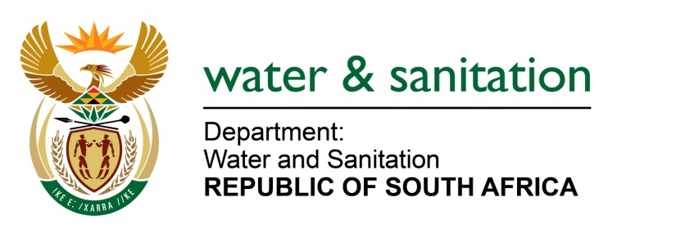

MINISTER OF WATER AND SANITATION

FOR WRITTEN REPLY

QUESTION NO 141

DATE OF PUBLICATION IN INTERNAL QUESTION PAPER: 10 FEBRUARY 2022
(INTERNAL QUESTION PAPER NO. 1)

141. Mr W Horn (DA) to ask the Minister of Water and Sanitation:

On what date (a) will construction of the water pipeline from the Xhariep Dam to the Mangaung Metropolitan Municipality commence and (b) is the construction envisaged to be completed?

NW145E
---00O00--

MINISTER OF WATER AND SANITATION

- Construction of the water pipeline from Xhariep Dam to Mangaung Metropolitan Municipality is scheduled to start in July 2025. The next phase of the project will comprise of detailed designs, securing funding and contracting agreements.

- It is envisaged that the project will be completed by June 2029.

