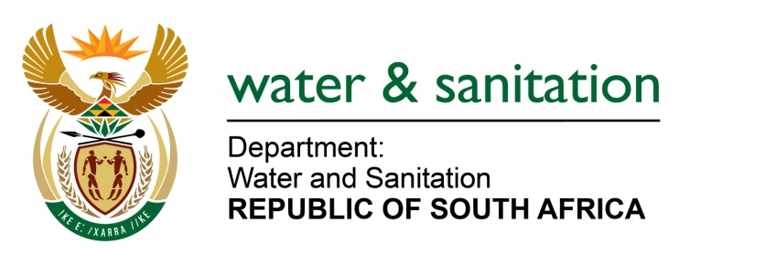

NATIONAL ASSEMBLY

FOR WRITTEN REPLY

QUESTION NO 1408

DATE OF PUBLICATION IN INTERNAL QUESTION PAPER: 22 APRIL 2022
(INTERNAL QUESTION PAPER NO. 14)

1408. Mrs C C S Motsepe (EFF) to ask the Minister of Water and Sanitation:
What are the reasons for the delays by his department in fixing the ageing infrastructure of wastewater treatment plants in the Emfuleni Local Municipality where residents are currently living with human excrement at their doorsteps?
NW1702E
---00O00---

MINISTER OF WATER AND SANITATION
The Department of Water and Sanitation has appointed Rand Water as the implementing agent for the sanitation intervention in Emfuleni. Funding has been allocated to Rand Water to rehabilitate four wastewater treatments works and to increase the capacity of the Sebokeng wastewater treatment works.
In addition, contractors are currently on site replacing collapsed sewer pipelines and removing blockages in sewer pipelines to stop sewage spilling into people’s yards and into the environment.
Rand Water is also assisting Emfuleni Municipality to improve the operation and maintenance of its wastewater treatment systems. It is anticipated that the rehabilitation of the wastewater treatment works will be completed by the end of this year.

---00O00---

