NATIONAL ASSEMBLY
36/1/4/1(201800140)

FOR WRITTEN REPLY

QUESTION 1408

DATE OF PUBLICATION IN INTERNAL QUESTION PAPER: 11 MAY 2018 (INTERNAL QUESTION PAPER NO 15-2018)

1408. Dr P J Groenewald (FF Plus) to ask the Minister of Police:

- What (a) number of firearms and (b) amount of state-owned ammunition in each province and office of the SA Police Service (SAPS) were respectively reported as stolen or as missing in each specified year (details furnished);

- (a) what number of such stolen and missing firearms are linked to crimes and
(b) what number of firearms and what amount of ammunition has been recovered;

- (a) what number of persons were successfully prosecuted regarding the theft of state-owned firearms and ammunition and (b) whether any SAPS officials were prosecuted for negligence or theft; if not, why not; if so, what number has been prosecuted for negligence and for theft,

- what measures has his department put in place to combat theft and loss of state-owned firearms and ammunition;

- whether he will make a statement on the matter2
NW1510E
REPLY:

(1)-(5) The information that is required is not readily available, as each case must be verified, before the information can be submitted. A request for an extension of three weeks is hereby made, to ensure that the information that is provided, is factually correct.

Original signed MAJOR GENERAL f/DIVISIONAL COMMISSIONER: DETECTIVE SERVICE (AOD) PP RAMATSOELE

Date: 11 May 2018

Reply to question 1408 recommended/not recommended

Original signed LIEUTENANT GENERAL DEPUTY NATIONAL COMMISSIONER: CRIME DETECTION LJ TSUMANE

Date: 17 May 2018

Reply to question 1408 recommended/

AL
OLE (SOEG)
GENERAL
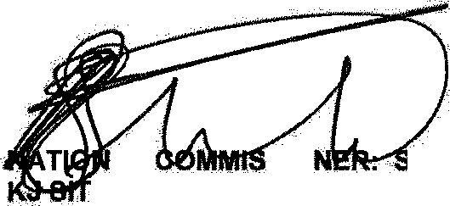
SIO iOUTH AFRICAN POLICE SERVICE

Reply to question 1408 approve‹f o ed
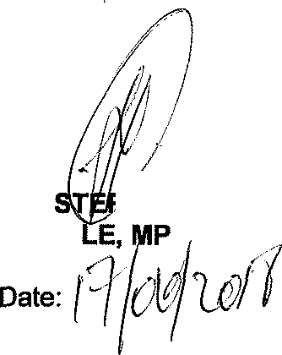

MINI POF POLICE
BH CE

