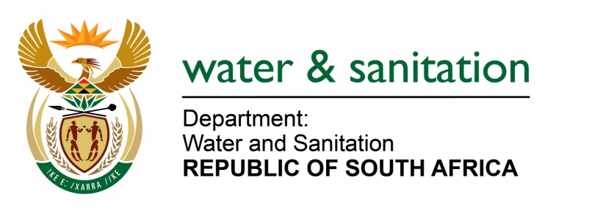

NATIONAL ASSEMBLY

FOR WRITTEN REPLY

QUESTION NO 1407

DATE OF PUBLICATION IN INTERNAL QUESTION PAPER: 22 APRIL 2022
(INTERNAL QUESTION PAPER NO. 14)

1407. Mrs C C S Motsepe (EFF) to ask the Minister of Water and Sanitation:
How will the wastewater challenge be funded which, according to the 2022 Green Drop Report, requires an amount of R8 billion in order to clean up the stinking sewage and wastewater crisis in the Republic?
NW1701E
---00O00---

MINISTER OF WATER AND SANITATION

The Department of Water and Sanitation uses the Green Drop Report as a performance baseline for the municipal wastewater fraternity to inform appropriate regulatory intervention with the objective to facilitate improvement. This is included in the Department’s Water Services Improvement Programme which includes sustainable intervention with the objective of ensuring a turnaround in the perfromance of the Municipal Water Services Sector.

The Green Drop Performance trends will be used to determine repetitive poor performance, to inform a more drastic approach to ensure a turn-around. This could include facilitating long-term intervention by either a capacitated water board or any other suitable mode of sanitation services support.

The results of the Green Drop Report dictates that wastewater services be a primary focus area of the government in targetted areas. Therefore, national government will ensure that grant funding allocated to the water sector is allocated with the objective of restoring the functionality of exisiting wastewater infrastructure according to the findings of this report.

The determination of the “Very Rough Order of Estimates” (VROOM), which informed the amount referenced in your question, was done to give an estimation of the capital requirement for the functionality restoration drive. This will be effected with the support of National Treasury.

---00O00---

