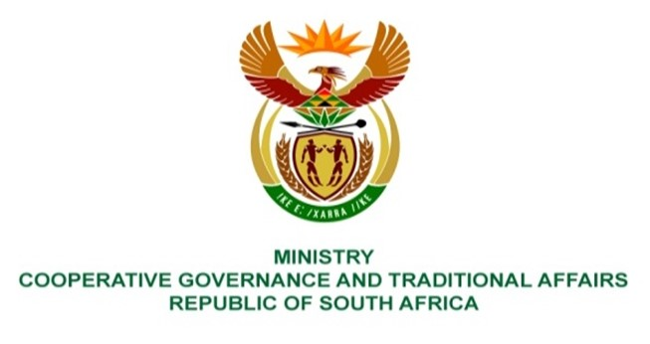

NATIONAL ASSEMBLY
QUESTION FOR WRITTEN REPLY

QUESTION NUMBER 1405
DATE OF PUBLICATION: 22 APRIL 2022

QUESTION:

1405. Ms H O Mkhaliphi (EFF) to ask the Minister of Cooperative Governance and Traditional Affairs:
What (a) led to the collapse of the Mangaung Metropolitan Municipality where section 139 of the Constitution of the Republic, 1996, was evoked, (b) are the names of the persons who were responsible for the dysfunction of the municipality and (c) consequence management has been applied to the specified persons? NW1699E

REPLY:
- The Mangaung Metropolitan Municipality (MMM) was officially placed under section 139(5)(a) and (c) intervention by the Free State Provincial Executive Council on 19 December 2019, due to a financial and service delivery crisis in the municipality. However, no significant progress has been made to implement the Financial Recovery Plan developed by National Treasury as a result of significant political interference in the administrative functioning of the Metro. Cabinet received a formal request from the Provincial Executive for a national intervention.

- Cabinet approved a national intervention in terms of Section 139(7) of the Constitution on 6 April 2022 to create stability and improve service delivery in Mangaung Metropolitan Municipality. A National Cabinet Representative supported by a multi-disciplinary team of experts are being deployed with responsibilities that will amongst others ensure and oversee the execution by the Accounting Officer of the functions referred to in Section 67(1)(h) and Schedule 2 of the Local Government: Municipal Systems Act, 2000 (Act No. 32 of 2000), read with any other relevant legislative provisions dealing with disciplinary matters, including criminal, disciplinary and civil action.

