MINISTRY OF TOURISM
REPUBLIC OF SOUTH AFRICA

Private Bag X424, Pretoria, 0001, South Africa. Tel. (+27 12) 444 6780, Fax (+27 12) 444 7027
Private Bag X9154, Cape Town, 8000, South Africa. Tel. (+27 21) 469 5800, Fax: (+27 21) 465 3216

Ref: TM 2/1/1/10

NATIONAL ASSEMBLY:

QUESTION FOR WRITTEN REPLY:
Question Number: 1405
Date of Publication: 26 May 2017
NA IQP Number: 18
Date of reply: 3 August 2017

Mr D America (DA) to ask the Minister of Tourism:

Has the Marketing Investment Framework econometric study conducted by her department with Oxford established an empirically derived optimal annual advertising spend to boost domestic tourism; if not, what is the position in this regard; if so, what (a) is this optimal annual domestic amount, (b) other relevant insights which can revitalise domestic tourism are contained in the study and (c) are the further relevant details in this regard? NW1547E
Reply;
The Marketing Investment Framework calculated R38 million as the optimal marketing spend to achieve SA Tourism’s 5-in-5 targets of 1 million more domestic holiday trips by 2021.
The Marketing Investment Framework calculation did not take into consideration South Africa’s macro-economic environment and barriers to domestic travel listed below:
- A constrained economy and high interest rates leading to high levels of unemployment;
- Lack of affordability due to low disposable income and restrained spending by consumers;
- The lack of culture of travel within the domestic market as South Africans do not see the value of travel.
Through the SA Tourism commissioned Domestic Segmentation Refresh Study and collaboration with Provincial Tourism Authorities, SA Tourism gained insights into the key drivers of domestic tourism and a renewed understanding of the identified market segments, ensuring their relevance in the current macro-economic environment.

SA Tourism used these insights to augment the outcome of the Marketing Investment Framework and increased the domestic marketing spend by an additional R100 million. SA Tourism is working with provinces to build a culture of travel and to drive conversion.

- Optimal annual domestic amount.

SA Tourism’s R138 million domestic marketing budget for the 2017/18 financial year has been apportioned as follows in order to address the barriers highlighted above:
- 50% of the total marketing budget has been allocated to drive awareness and to build a culture of travel amongst South Africans who currently have no culture of travel though the “I Do Tourism” Campaign.
- The remaining 50% of the budget has been set aside to drive conversion with trade through affordable local packages and to drive demand for more frequent domestic short breaks.

Going forward, some of this budget will be focussed more towards investing in tourism development driven by the National Department of Tourism in order to increase supply of quality and affordable products into the market, thereby ensuring a balance between stimulation of demand and strengthening the supply base.

- Other relevant insights which can revitalise domestic tourism that are contained in the study
The Domestic Tourism Marketing Strategy is informed by a segmentation refresh study that was recently undertaken, to enable better targeting of the identified consumer segments, which will inform refreshed messaging and communications. The domestic study found that there are almost 22 million South Africans with a source of income, who can be seen as potential tourists.

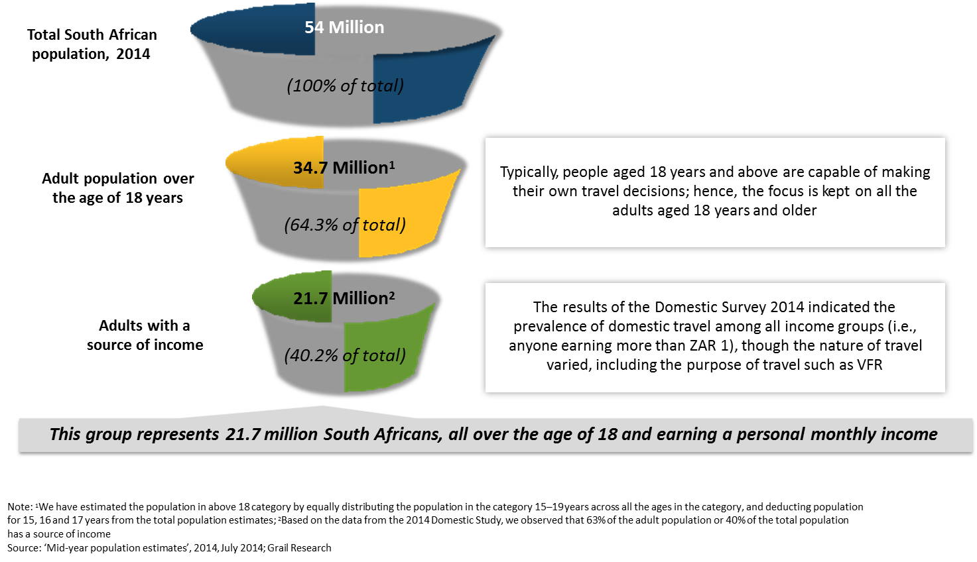

(c) Further details
The Domestic Tourism Marketing Strategy will focus on building the culture of travel, converting the travelling population (especially those who travel mainly to visit friends and relatives) to start taking holidays, and encouraging existing holiday-makers to take more holidays.

The research identified three groups of people to target:

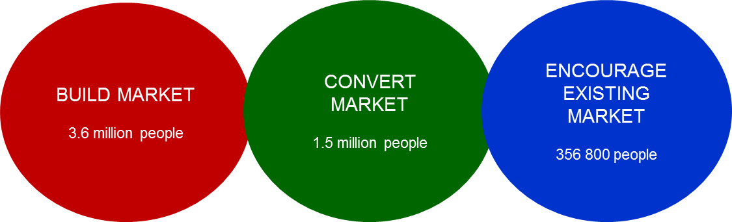

- Build Culture of Travel
In order to broaden the opportunity for growing domestic tourism, South African Tourism will build the culture of travel among South Africans. Initiatives and programmes to build a travel culture will target 3.6 million consumers with adequate disposable income yet not travelling as much as they could.
- Convert Travelling Population
This population of approximately 1.5 million people is already travelling to a certain extent, but not necessarily for holiday purposes. They buy into the “experience economy” and aspire most to travelling overseas and exploring other countries, prioritising such trips over domestic trips – especially if they are offered a good deal. Since they do not always have the means to travel, they are looking for affordable options, and will prioritise travel if and when inspiration strikes.
- Encourage Existing Holiday Makers
This group of about 350 000 people are considered “mature” in terms of holiday travel. They are happy to pay for convenience when travelling, because their time is precious. They enjoy going on holiday seasonally to spend time bonding with their family, and their children are their main priority.
With these domestic tourism focus areas in mind, as well as taking into account key barriers to travel such as affordability and accessibility, South African Tourism aims to:
- Excite and entrench a tourism culture among South Africans by partnering with community structures across all provinces (including rural areas), supporting affordable trade offers and other catalytic platforms supported by media and influencers for first-time tourists.

- Grow the number of domestic tourists and the frequency of trips by targeting the prioritised segments. This will be done by engaging in activities (including product placement through media channels) that will drive demand by changing consumers’ attitude towards the desirability and value of domestic travel.

- Increase the contribution of tourism revenue to the economy by targeting holiday leisure tourists as well as business tourists, with the intention of converting business tourists into leisure tourists by promoting leisure tourism add-ons to business trips in partnership with the trade. VFR tourists will also be motivated to embrace more leisure tourism activities.

- Enhance efforts to address seasonality by developing deal-driven tactical campaigns with trade partners to stimulate bookings during the low season, from May to September. Day trips will be encouraged through initiatives such as special offers or discounts to make attractions affordable for all.

- Achieve improved geographic spread by partnering with provincial tourism agencies to build content and itineraries of new and innovative products for packaging by trade partners. This will include highlighting the “hidden gems” in less-visited provinces and promoting World Heritage Sites and other iconic cultural attractions. The strategy will leverage off provincial strategic events and resources to grow domestic tourism and increase the share of tourism for the respective provinces. This calls for the alignment of plans and strategies, as well as for the monitoring of their successful implementation.

