MINISTRY OF TOURISM
REPUBLIC OF SOUTH AFRICA

Private Bag X424, Pretoria, 0001, South Africa. Tel. (+27 12) 444 6780, Fax (+27 12) 444 7027
Private Bag X9154, Cape Town, 8000, South Africa. Tel. (+27 21) 469 5800, Fax: (+27 21) 465 3216

Ref: TM 2/1/1/10

NATIONAL ASSEMBLY:

QUESTION FOR WRITTEN REPLY:
Question Number: 1404
Date of Publication: 26 May 2017
NA IQP Number: 18
Date of reply: 12 June 2017

Mr M R Bara (DA) to ask the Minister of Tourism:

Has the Marketing Investment Framework econometric study conducted by her department with Oxford established an empirically derived optimal annual advertising spend to attract overseas visitors to South Africa; if not, what is the position in this regard; if so, what (a) is this optimal annual overseas advertising budget, (b) did the study reveal in terms of which countries South Africa should be advertising in and (c) are the further relevant details in this regard? NW1546E

Reply;

Yes. South African Tourism sets its baseline using the Oxford Econometrics Target Setting Methodology.
The Econometrics Model predicts what world travel should be in 190 global markets (including South Africa), then each country assumes a certain share of that based on how it performs against certain measures.

- Tourism Demand modelled as a function of:

- Macro-economic drivers:
- GDP
- GDP per capita
- Consumer spending
- Income
- Personal disposable income

- Demographics:
- Population
- Working Age
- Employment Rate

- Prices:
- Consumer Price Index
- Interest Rates

- Destination Competitiveness Index:
- Regulatory Framework
- Environment
- Infrastructure
- Resources (Human, cultural and natural)

Through the Marketing Investment Framework consideration was given to the tourism potential of various markets, South Africa’s ability to win in those markets and the cost of acquisition of tourists from those markets. This has informed the organisation’s marketing spend in each international market.

- Optimal Annual Overseas advertising Budget
SA Tourism’s approved international marketing budget for the 2017/18 financial year is R 804 million (approximately 60% of the organisation’s total approved budget). This is the optimal marketing spend to assist the organisation in achieving its 5-in-5 target of 4 million more international tourist arrivals by 2021.

- What did the study reveal in terms of which countries SA should be advertising in?
Based on the desired growth in market share, relative cost of acquisition in each market and the available budgets, South African Tourism has defined a selection of prioritised markets from the list of attractive opportunities. These markets are expected for account for 95% of total international trips to South Africa.

The Marketing Investment Framework’s selection of markets is as follows:

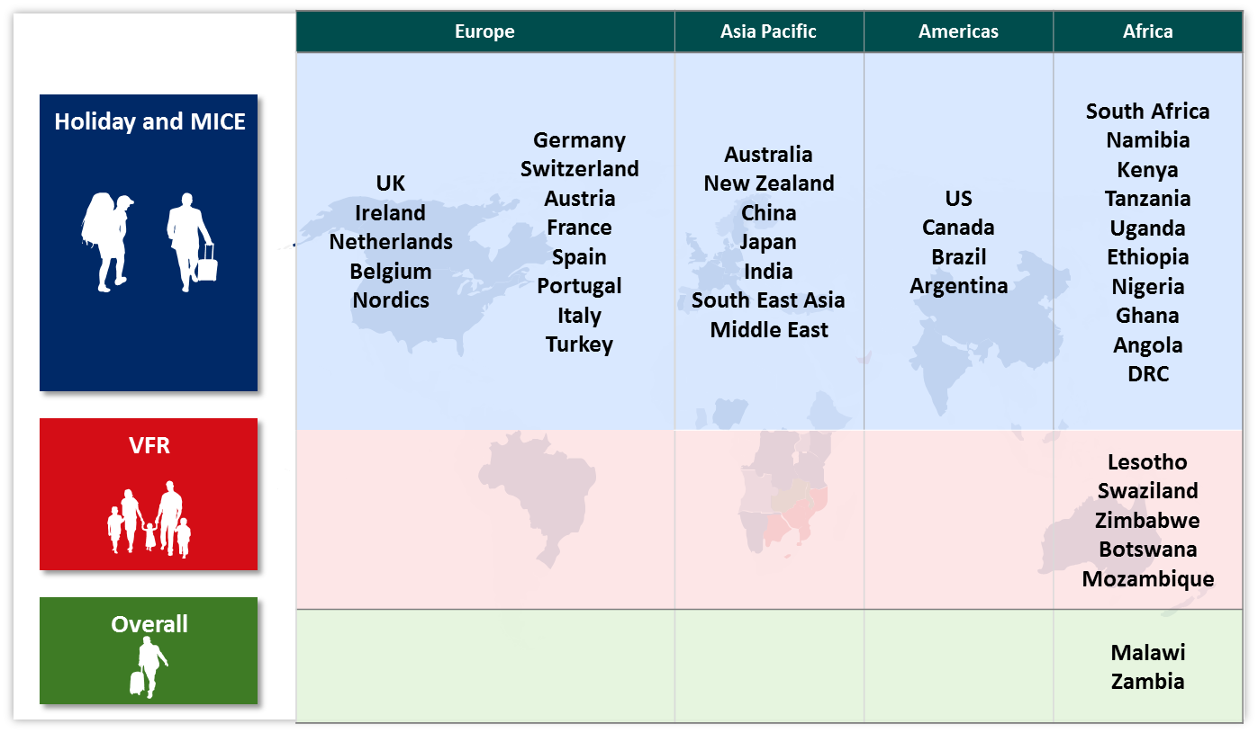

These markets have been divided into international markets with the highest share of holiday and (Meetings, Incentives, Conferencing and Exhibitions (MICE) trips to South Africa, markets with the highest share of Visiting Friends and Relatives (VFR) trips to South Africa, and markets with the highest share of trips for other purposes, such as for trading purposes.

(c) Further details

SA Tourism’s strategic plan for 2017-2022 provides full details of SA Tourism’s approach in arriving at the Marketing Investment Framework and selected markets for investment. A detailed Marketing Investment Framework information pack can be provided on request.

