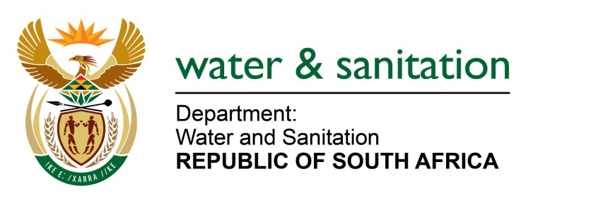

NATIONAL ASSEMBLY

FOR WRITTEN REPLY

QUESTION NO 1203

DATE OF PUBLICATION IN INTERNAL QUESTION PAPER: 27 MARCH 2015
(INTERNAL QUESTION PAPER NO. 9)
1203. Mr L J Basson (DA) to ask the Minister of Water and Sanitation:
(1) In which municipalities are the estimated 88 127 bucket toilets in formal areas;
(2) how many bucket toilets are there in respect of each municipality;
(3) what is the (a) timeframe and (b) cost of replacing these bucket toilets? NW1408E
---00O00---
REPLY:

(1) A study conducted in July 2012 suggested that the backlog for buckets in formal areas is estimated at 58 010; a substantial drop from the 88 127. The latter was further clarified in as far as the Nelson Mandela Bay Metro which had 19 444 buckets with an unsubstantiated claim of a further 100 buckets in the informal areas which was to be deducted from the 88 127. A second clarification came from the Free State Province in that the initial backlog was 42 815, however, after clarification reduced to 32 042 (a drop in 10 773), thus arriving at 57 910 in formal areas.

However, the Department has verified the buckets in formal areas which amount to 58 453.

(2) Refer to table below.

Province | Municipality | Project Name | Total
Eastern Cape | Makana | Grahamstown | 737
 | Makana 2 | Grahamstown | 288
 | Sundays River Valley | Patterson | 1245
 | Baviaans | Steyterville | 14
 | Joe Ggabi | Steynburg | 985
 | Chris Hani | Indwe | 89
 | Ikhwezi | Jansenville | 21
 | Blue Crane | Somerset east | 4
 | Ndlambe | Nemato | 2230
TOTAL |  |  | 5613

Province | Municipality | Project Area | Total
Northern Cape | Dikgatlong | Proteahof | 277
 |  | Koopmansfontein | 37
 | Phokoane | Malelwane | 85
 | Ga-Segonyana | Bathlaros | 498
 | Emthanjeni | Britstown | 424
 | Thembelihle | Hopetown | 52
 | Tsantsabane | Maranteng | 791
 |  | Postdene | 450
 | KharaHais | Rosedale | 2682
 |  | Pabalello | 533
 |  | Louisvale | 800
 |  | DekotaWeg | 306
 |  | Kameelmond | 122
 |  | Kalksloot | 138
 | Renosterburg | PetrusvillePh 2 | 20
 |  | Phillipstown | 107
 | Siyacuma | Breipal | 282
 |  | Bongani | 555
 |  | Bongani - Reservoir | 49
 |  | BonganiPhomolong | 31
 |  | Griekwastad | 527
 |  | Campbell | 596
 | Siyathemba | Marydale | 175
 | Sol Plaatjie | Ritchie | 1345
 |  | Freedom Park | 167
 |  | Promised Land | 787
 | Ubuntu | Victoria West | 890
 | Nama-Khoi | Various Sites | 192
 | Kai Garib | Various Sites | 800
TOTAL |  |  | 13 718

North West | City of Matlosana | Jouberton /Kanana | 293
 |  | Kanana | 73
 | LekwaTeemane | Boitumelong | 230
TOTAL |  |  | 596

-3-

Province | Municipality | Project Area | Total
Free State | Mohokare | Smithfield | 148
 |  | Fauresmith | 36
 |  | Bethulie | 23
 |  | Trompsburg | 149
 |  | Zastron | 90
 |  | Rouxville | 756
 | Naledi | Dewetsdorp | 191
 | Dihlabeng LM | Rosendal | 976
 | Mantsopa LM | Tweespruit | 1266
 |  | Hobhouse | 1224
 | Phumelela LM | Memel | 568
 |  | Vrede | 150
 | Mafube LM | Cornelia | 612
 |  | Villiers | 1056
 |  | Frankfort | 2105
 |  | Tweeling | 304
 | Ngwathe LM | Heilbron | 1584
 |  | Vredefort | 1120
 | Nala LM | Wesselsbron | 1800
 | Masilonyana LM | Theunissen | 1438
 |  | Hennenman | 2848
 |  | Winburg | 180
 | Matjhabeng LM | Virginia | 2240
 | Matjhabeng LM | Odendaalsrus | 264
 | Tokologo LM | Hertzogville | 294
 | Setsoto LM | Marquard | 1431
 |  | Ficksburg | 5396
 |  | Senegal | 2913
 |  | Clocolan | 3379
 | Nketoana | PetrusSteyn | 2424
 |  | Lindley | 517
 |  | Arlington | 210
 |  | Reitz | 834
TOTAL |  |  | 38526

(3)(a) All buckets in the formal areas will be eradicated by end of the financial year.

(3)(b) The programme is estimated to cost R975 339 000,00.

---00O00---

