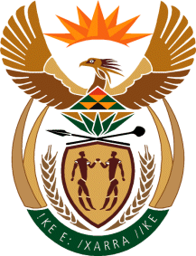

MINISTER IN THE PRESIDENCY: REPUBLIC OF SOUTH AFRICA
Private Bag X1000, Pretoria, 0001, Union Buildings, Government Avenue, PRETORIA
Tel: (012) 300 5200, Website: www.thepresidency.gov.za

NATIONAL ASSEMBLY – INTERNAL QUESTION PAPER

QUESTION FOR ORAL REPLY

QUESTION NUMBER: 1401

Mr M W Rabotapi (DA) to ask the Minister in The Presidency:

Whether (a) his department and (b) all entities reporting to him are running development programmes for (i) small businesses and (ii) co-operatives; if not, why not; if so, in each case, (aa) what are the relevant details, (bb) what amount has been budgeted and (cc) how many jobs will be created through the specified development programmes in the 2016-17 financial year?
[NW1549E]

REPLY:
The NYDA is running the following programs:
- Business Support Services – Voucher Programme
- Market Linkages
- Mentorship
- Grant Programme
- Entrepreneurship Development Programme
- Cooperative Governance Training
- Business Registration Service
R50, 3m is allocated for all the Economic Development Programmes.

The Department of Planning Monitoring and Evaluation (DPME) does not run dedicated development programmes but it does encourage SMMEs to register on its supplier database and endeavours to utilise these companies where possible when procuring goods and services.

Statistics South Africa does not run any development programme for small business. However, it gathers data and collates such data into statistical information that would certainly be of use to small business. A dedicated survey for the self-employed is periodically conducted to inform what takes place in the informal sector.

