MINISTER FOR HUMAN SETTLEMENTS: N C MFEKETO, MP DIRECTOR-GENERAL: M S TSHANGANA

NATIONAL ASSEMBLY
QUESTION FOR WRITTEN REPLY QUESTION NUMBER: 1400 (NW1502E) DATE OF PUBLICATION: 11 MAY 2018

REPLY RECOMMENDED BY:
DEPUTY DIRECTOR-GENERAL: MR. J LESHABANE

NATIONAL ASSEMBLY QUESTION FOR WRITTEN REPLY
ouEsTlON NUMBER: 1400 (NW1502E)
DATE OF PUBLICATION: 11 MAY 2018

Ms NKF Hlonyana (EFF) to ask the Minister of Human Seklemente:

- What is the number of houses that needs to be built in each province to eradicate the housing backlog and enable each South African in the country to live in formal housing?

Reelv

According to information derlved from Statistics South Africa's 2016 Community Survey, which is the latest official national data available, the estimated national housing backlog is estimated at 2.1 million. On the other
hand, a total of 3.9 million people have registered their need for housing on the National Housing Needs Register (NHNR). It must however be noted that the numbers registered on the NHNR are being processed on an on-going basis to determine qualification for government's subsidised opportunities. So this is work in progress and not actual demand/need. Although significant inroads have been made to reduce the backlog, it remains relatively the same over years due to increasing demand that outstrips supply. The provincial breakdown of the backlog/need is illustrated in the table below.
Province | Informal dwellings (dwellings In informal settlements & backyards) | National Housing Needs Register
Eastern  Cape | 130 885 | 1 185 502
Free State | 13Z 448 | 4B3
Gauteng | 878 246 | 1 932 346
KwaZulu  Natal | 245 167 | 20 695
Limpopo | 77 371 | 20 525
Mpumalanga | 135 039 | 104 577
Northern  Cape | 45 246 | 188 807
North West | 229 544 | 25 881
Western  Cape | 320 022 | 208 803
5A Total | 2 193 8b8 | 3 090 709

What is the cost in Rand for each province to eradicate the backlog?

ReDIv
As explained in question (a) above, the assessment of individuals who have registered on the NHNR to determine if they do qualify for state housing subsidy is an ongoing process. Therefore some of the individuals may not be eligible to receive a state housing subsidy. Those who do qualify, may require different housing programme interventions, depending on their need and locality. If all the individuals on the NHNR qualify for the Individual Housing Subsidy (BNG house), about R622 billion will be required to provide land, serviced site and top structure at the current housing subsidy of R168 852.00.

PrOV t3C6 National Housing Needs Register | Cost to eradicate the bachlog (ass above explanation)
Eastern Cape 1 185 502 | R200 174 383 704
Free State 483 | R81 555 51G
Gauteng 1 932 346 | R326 280 486 792
KwaZulu Natal 20 695 | R3 494 392 14£
Limpopo 20 525 | R3 465 687 30€
Mpumalanga 104 577 | R17 658 035 604
Northern Cape 188 897 | R31 895 636 244
North West 25 881 | R4 370 058 612
Western Cape 208 803 | R35 256 804 15£
SA Total 3 980 708 | R622 877 040 08£

NATIONAL ASSEMBLY QUESTION FOR WRITTEN REPLY
QUESTION NUMBER: 1400 (NW1502E) DATE OF PUBLICAYION: 11 MAY 2018

MR J. LESHABANE
DEPUTY DIRECTOR GENERAL DATE:

MR N CHAINEE
DEPUTY AIR CTOR-GENERAL: CHIEF OF OPERATIONS
DATE: il } g‘

Recommended/not res6mmended

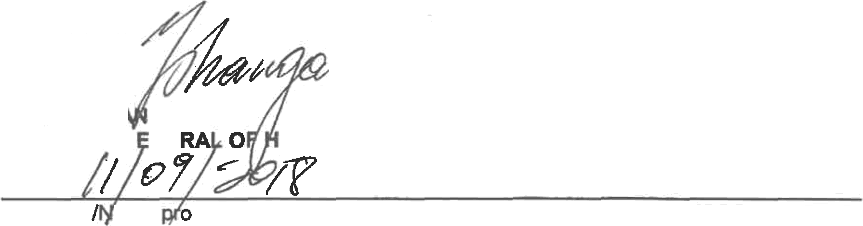
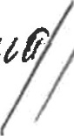
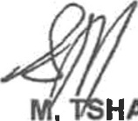
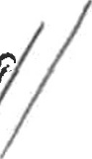
MI . H4 GANA DIRECTOR-G NE DATE:
Approved ot ap ved

UMAN SETTLEMENTS

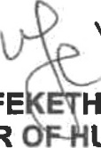
MS N. MFE HO,
MINISTER UMAN SETTLEMENTS

DATE:

