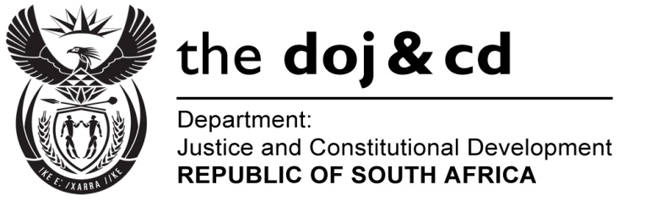
NATIONAL ASSEMBLY
QUESTION FOR WRITTEN REPLY
PARLIAMENTARY QUESTION NO: 1398
DATE OF QUESTION: 13 MAY 2016

DATE OF SUBMISSION: 27 MAY 2016
Ms T Stander (DA) to ask the Minister of Justice and Correctional Services:
Whether (a) his department and (b) all entities reporting to him are running development programmes for (i) small businesses and (ii) co-operatives; if not, why not; if so, in each case, (aa) what are the relevant details, (bb) what amount has been budgeted and (cc) how many jobs will be created through the specified development programmes in the 2016-17 financial year?
NW1546E
REPLY:

I wish to inform the Honourable Member that I have been informed that:-
- Neither the Department of Justice and Constitutional Development nor the Office of the Chief Justice; nor
- The National Prosecuting Authority, Legal Aid Board South Africa or the Special Investigating Unit, are running development programmes for (i) small businesses and (ii) co-operatives, because this is not the core function of the Departments and/or entities involved.

The Departments and entities involved, are supporting the programmes and initiatives such as the Central Supplier Database (CSD) at present being developed and implemented by the National Treasury, the Department of Trade and Industry as well as the Department of Small Business Development.

(a) Department of Correctional Services through the services of the Directorate Skills Development does not directly run development programmes.

(b) and (ii) small businesses and co-operatives focus is on the development of incarcerated offenders through various skills in the following categories:

- Technical Vocational Education and Training Programme e.g N-Courses & NCV Programmes.
- Occupational Skills Training Programmes, e.g. welding, woodwork, computer skills, entrepreneurship and electrical programmes.
(aa) The Directorate Skills Development provides the above skills development programmes to offenders and also as its mandate ensures that skilled offenders are empowered on entrepreneurial skills so that they can create employment opportunities through small business ventures upon release.
Since the Department does not have the capacity to provide the afore-mentioned entrepreneurial skills to offenders, the Department collaborates with external state agencies such as Small Enterprises Development Agency (SEDA), National Youth Development Agency (NYDA) and the National Skills Funds (NSF) for assistance.

(bb) No budget is specifically allocated for entrepreneurship programmes, hence the above initiative of collaboration with other external stakeholders.
(cc) There is no specific target set to create jobs as the mandate of Skills Development is mainly to provide offenders with needs - based programmes and interventions to facilitate their rehabilitation and personal development.
The Department had previously identified a need for partnering with the Small Enterprises Development Agency (Seda) which is the agency of the Department of Small Business Development in order to train and offer support through its business support officers to offenders participating in Skills Development programmes, Production Workshops and Agriculture and Maintenance programmes in order to ensure that they (i.e. offenders) are exposed to business opportunities and are able to start planning for their own small business enterprises to be pursued upon release.

In preparation for this initiative the Department consulted SEDA in this regard. Hence SEDA conducted an Entrepreneurship Training Workshop during October 2016 which resulted in a total of 16 officials from all regions trained as Entrepreneurs Ambassadors so as to can facilitate future SMME related programmes in the interest of offenders. Furthermore during the period September 2014 and March 2015 a total of 50 offenders in KZN were trained on the Empretec Entrepreneurship Training pilot training in DCS (22 offenders from New Castle Management Area and 28 from Ekuseni Youth Centre).

In light of the above, the Department of Small Business Development (DSBD) has agreed in principle to participate in the SMME awareness campaign and capacity building sessions particularly to those offenders who are due to be released as well as those who participate in Skills Development Programmes. Although a formal MoU between DCS and DSBD has not been finalised, the Department is planning to co-host a National Exhibition and an SMME Campaign for offenders in 2016/2017 financial year.

