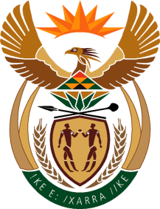

MINISTRY OF TOURISM
REPUBLIC OF SOUTH AFRICA

Private Bag X424, Pretoria, 0001, South Africa. Tel. (+27 12) 444 6780, Fax (+27 12) 444 7027
Private Bag X9154, Cape Town, 8000, South Africa. Tel. (+27 21) 469 5800, Fax: (+27 21) 465 3216

NATIONAL ASSEMBLY:

QUESTION FOR WRITTEN REPLY:
Question Number: 1397
Date of Publication: 21 May 2021
NA IQP Number: 14
Date of reply: 29 May 2021

Mr M S F de Freitas (DA) to ask the Minister of Tourism:
(a) How are (i) service providers and (ii) suppliers who default in the services that they render to the SA Tourism dealt with, (b) what number of service providers and suppliers have defaulted in each month in the past three financial years and since 1 April 2021, (c) what are the reasons for default in rendering the services, (d) what steps are taken to reduce the default incidences and (e) what financial losses have been incurred in each month in the past three financial years and since 1 April 2021?
NW1591E

REPLY:

- (i) South African Tourism has never had any suppliers that defaulted in any of the contracts from the past three years and since 1 April 2021.
- Not applicable

- Not applicable
- Not applicable since no suppliers defaulted for the past three years and since 1 April 2021.
- Not Applicable
- No financial losses have been incurred in the past three financial years and since 1 April 2021

