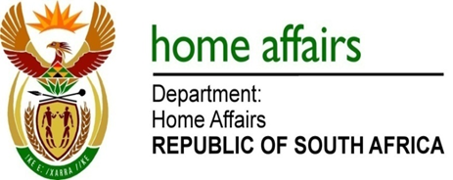

NATIONAL ASSEMBLY

QUESTION FOR WRITTEN REPLY

QUESTION NO. 1395

DATE OF PUBLICATION: Friday, 13 May 2016

INTERNAL QUESTION PAPER 14 OF 2016

1395. Mr. B R TOPHAM (DA) to ask the Minister of Home Affairs:

Whether (a) his department and (b) all entities reporting to him are running development programmes for (i) small businesses and (ii) co-operatives; if not, why not; if so, in each case, (aa) what are the relevant details, (bb) what amount has been budgeted and (cc) how many jobs will be created through the specified development programmes in the 2016-17 financial year? NW1543E
REPLY:

No, the security nature of Home Affairs and Government Printing Works business is not geared towards development programmes for small business and cooperatives but we do provide direct contractual work to small business where applicable.

