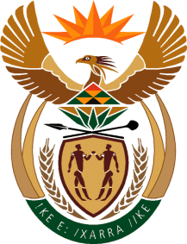

MINISTRY OF TOURISM
REPUBLIC OF SOUTH AFRICA

Private Bag X424, Pretoria, 0001, South Africa. Tel. (+27 12) 444 6780, Fax (+27 12) 444 7027
Private Bag X9154, Cape Town, 8000, South Africa. Tel. (+27 21) 469 5800, Fax: (+27 21) 465 3216

NATIONAL ASSEMBLY:

QUESTION FOR WRITTEN REPLY:
Question Number: 1385
Date of Publication: 21 May 2021
NA IQP Number: 14
Date of reply: 29 May 2021

Mr P G Moteka (EFF) to ask the Minister of Tourism:
In view of the Auditor-General’s finding that the R24 million which was put aside for the construction of a tourist site in Barberton was never used for that purpose, (a) what steps has she taken to find out what happened to the money and (b) have any departmental officials been suspended for this? NW1579E
REPLY:

- There were no challenges associated with this project that were raised by the Auditor General. The Department funded initiatives to enhance the tourism experience at the Barberton Makhonjwa Mountains prior to the listing of the site as a UNESCO World Heritage Site (WHS). The project was initiated in 2010 and completed in 2014 with a total budget of R 24 784 279. The project was implemented by the Barberton Chamber of Business. The Barberton Tourism and Biodiversity Corridor programme was supported by the provincial tourism department, Umjindi Local Municipality, Chief Albert Luthuli municipality, Nkomazi municipality, tourism businesses, research academics and the Department of Environmental Affairs. The project was successfully completed and handed over to the owning entity.

(b) Not applicable

