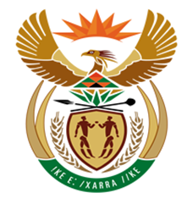

NATIONAL ASSEMBLY

QUESTION FOR WRITTEN REPLY
QUESTION NUMBER: 1381 [NW1523E]
DATE OF PUBLICATION: 26 MAY 2017

1381. Mr R A Lees (DA) to ask the Minister of Finance:

(1) Whether a certain official (COMMISSIONER) has received (a) a final report, (b) any preliminary reports and/or (c) any progress reports in respect of the investigation being conducted by certain firm (HOGAN LOWELS) into allegations relating to a certain person (MR JONAS MAKWAKWA); if not, in each case, why not; if so, (i) what is the title of the report and (ii) on what date was the report received in each case;

(2) what is the (a) total cost and (b) detailed breakdown of such costs of the investigation;

(3) whether he will make a statement on the matter?
NW1523E

REPLY:

- The Commissioner of SARS has received a final report on 09 June 2017; the title of the report is “The South African Revenue Service. Final Report. Investigation into allegations contained in the FICA report : MJ Makwakwa and KA Elskie”

- Given that the process is still ongoing, we are at this stage unable to provide a determination of costs in this regard.

(3) Minister will not be making any statement on the matter at this point.

