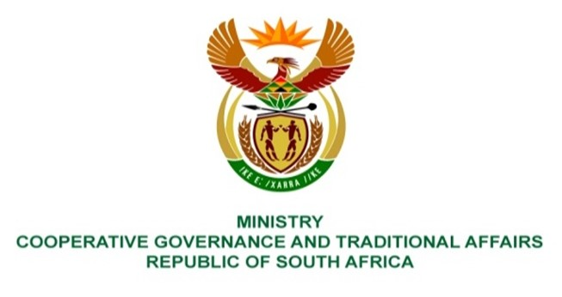

NATIONAL ASSEMBLY
QUESTIONS FOR WRITTEN REPLY

QUESTION NUMBER 1380
DATE OF PUBLICATION: 2022

QUESTION:

1380. Mr K Ceza (EFF) to ask the Minister of Cooperative Governance and Traditional Affairs:
What actions have been taken by her department to (a) close the infrastructural backlog in townships and informal settlements regarding (i) sewer spillage, (ii) pit toilets, (iii) disaster management and (iv) fire departments and (b) monitor water in rural areas under water services authorities? NW1672E
REPLY

- The Department of Cooperative Governance (DCOG) has taken various actions aimed at improving service delivery and eradicating infrastructure backlogs that include the following:

- DCOG together with the Municipal Infrastructure Support Agent (MISA), all provincial departments responsible for local government and provincial treasury departments, under the leadership of the Minister of COGTA, prepared the State of Local Government (SOLG) report that was tabled and considered by Cabinet in June 2021. Cabinet’s resolutions on the SOLG report included that COGTA and National Treasury should lead the process of the development of the Municipal Support and Intervention Plans (MSIPs) in collaboration with sector departments, SALGA, provinces and municipalities. MSIPs have since been prepared that aim, among other things, to address sewer spillages and eradication of infrastructure backlogs.

- MISA continues to provide technical support by deploying professionally registered Engineers and Town and Regional Planners to low and medium capacity municipalities, in accordance with the District Development Model. Currently MISA has deployed over 150 technical personnel to support and build the capacity of municipalities in infrastructure development and service delivery. The technical support by the MISA technical personnel includes assisting municipalities to develop operation and maintenance plans of the sewage system and implementation thereof. MISA also builds municipalities’ technical capacity by placing built environment learners in various low and medium capacity municipalities as part of the apprenticeship programme, the experiential learnership programme and the young graduates’ programme. In the last financial year MISA enrolled a total of 252 learners and candidates of the three programmes in various municipalities. Furthermore MISA, trains municipal officials in technical refresher courses. MISA trained 519 municipal officials in the last financial year in technical courses.

DCOG is administering the Municipal Infrastructure Grant (MIG) whose purpose is to provide specific capital finance for eradicating basic municipal infrastructure backlogs for poor households, microenterprises and social institutions servicing poor communities. The infrastructure includes for sanitation services. MISA supports municipalities with the implementation of projects throughout the project life cycle. Some of the specific activities of support are as follows:

- Review of projects business plans and technical reports for registration
processes,
- General project management and project implementation planning
- Verification of work done on infrastructure projects
- Invoice verification on the MIG funded projects prior payment to ensure
value for money is created on the ground.

- All 44 District Municipalities and all 8 Metropolitan municipalities have established and operates disaster management centres in its municipal areas. These disaster management centres in partnership with the respective national, provincial municipal organs of state develop disaster management plans setting out the way in which the concept and principles of disaster management are to be applied in its functional area. These plans form part of and is implemented through the Integrated Development Plan and the Service Delivery Budget Implementation Plan.

Furthermore, the Department of Cooperative Governance and Traditional Affairs (COGTA) provides support through Disaster Grant funding allocations to augment the resources of the municipalities affected by disaster in case their resources have been depleted and municipalities are unable to cope only utilising own funding. During financial year 2021/2022, grant funding allocations were made to municipalities affected by disasters for drought and flood intervention measures, particularly infrastructure projects.

- (iv) The NDMC has developed the White Paper on Fire Services which provides a framework for understanding the philosophy and approach in the delivery of fire services in the country going forward and these build on the good practice found in today’s fire service across the country and globally. In the past financial year 2021/2022, the NDMC has conducted Ten (10) Fire Safety and prevention capacity assessment across the country and reports were submitted to relevant accounting officers for immediate attention and implementation. In addition, the NDMC has also supported municipalities via different provinces with Urban Search and Rescue (USAR) training. Thus, capacity building projects were provided to North West, KZN, Gauteng and Western Cape and will proceed to other provinces.

- MISA continues to support low and medium capacity municipalities by deploying technical personnel in accordance with the District Development Model (DDM).

In the 2021/22 financial year, MISA prioritized interventions through the mainstreaming of groundwater projects by rehabilitating and drilling of boreholes, spring refurbishment and protection, providing storage and reticulation across the country through its own budget and in some instances in collaboration with the Development Bank of Southern Africa (DBSA). The groundwater mainstreaming interventions in 2021/22 financial year resulted in a total of 78 boreholes drilled and springs protected as follows:

- 39 boreholes were completed
- 3 springs were protected and completed
- 32 borehole projects from last financial year are continuing in the 2022/23 financial year, and
- 4 springs protection projects are continuing in the 2022/23 financial year.

The monitoring of water quality is done by the Department of Water and Sanitation (DWS). MISA supports municipalities to ensure to compliance with legislation and meeting service standards.

