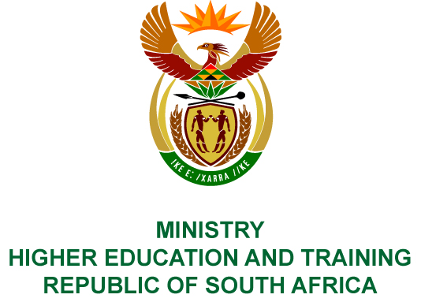
Private Bag X893, Pretoria, 0001, Tel (012) 312 5555, Fax (012) 323 5618
Private Bag X9192, Cape Town, 8000, Tel (021) 469 5150, Fax: (021) 465 7956
Memorandum from the Parliamentary Office
NATIONAL ASSEMBLY
FOR WRITTEN REPLY
QUESTION 138
DATE OF PUBLICATION OF INTERNAL QUESTION PAPER: 08/02/2018

(INTERNAL QUESTION PAPER NO 1 OF 2018)
Ms N Nolutshungu (EFF) to ask the Minister of Higher Education and Training:
(1) How many officials and/or employees in her department were granted permission to have businesses and/or do business dealings in the past three financial years;
(2) are any of the officials and/or employees that have permission to have businesses and/or do business dealings doing business with the Government; if so, (a) what was the purpose of each business transaction, (b) when did each business transaction occur and (c) what was the value of each business transaction?
NW145E
REPLY:
(1) The details of the number of officials and financial years are provided below:
2015/16 | 2016/17 | 2017/18
0 | 22 | 1
(2) No official has requested approval to conduct business with an organ of the state:
- Not applicable.
- Not applicable.
- Not applicable.

