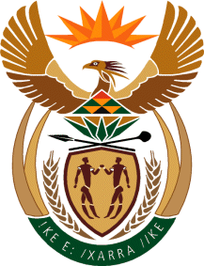

MINISTRY: COMMUNICATIONS
REPUBLIC OF SOUTH AFRICA
Private Bag X 745, Pretoria, 0001, Tel: +27 12 473 0164 Fax: +27 12 473 0585
Tshedimosetso House,1035 Francis Baard Street, Tshedimosetso House, Pretoria, 1000

NATIONAL ASSEMBLY
QUESTION FOR WRITTEN REPLY
QUESTION NUMBER: 138
DATE OF PUBLICATION: 9 FEBRUARY 2017
Ms V van Dyk (DA) to ask the Minister of Communications:
- Have the monthly EMP201 payments that were not submitted in the 2015-16 financial year due to the ill health of the Acting Chief Financial Officer (CFO) been submitted yet; if not, why not, if so, (a) how and (b) when;
- What measurements are in place for the 2016-17 financial year to ensure that the Media Development Diversity and Agency (MDDA) complies with the law and regulations regarding EMP201 payments?
REPLY: MINISTER OF COMMUNICATIONS
(1) Yes, SARS account is currently up to date.
(a) Face to face engagement with SARS to rectify the account.
(b) April 2016.
(2) Recruitment of a Finance and Payroll Administrator to ensure segregation of duties and business continuity in the absence of a senior Manager.

MR NN MUNZHELELE
DIRECTOR GENERAL [ACTING]
DEPARTMENT OF COMMUNICATIONS
DATE:

MS AF MUTHAMBI (MP)
MINISTER OF COMMUNICATIONS
DATE

