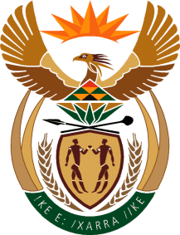

MINISTER OF TOURISM
REPUBLIC OF SOUTH AFRICA

Private Bag X424, Pretoria, 0001, South Africa. Tel. (+27 12) 444 6780, Fax (+27 12) 444 7027
Private Bag X9154, Cape Town, 8000, South Africa. Tel. (+27 21) 469 5800, Fax: (+27 21) 465 3216

NATIONAL ASSEMBLY:

QUESTION FOR WRITTEN REPLY:
Question Number: 1378
Date of Publication: 26 October 2019
NA IQP Number: 22
Date of reply: 04 October 2019

Dr M M Gondwe (DA) to ask the Minister of Tourism:

Whether her department did business with certain (a) persons, (b) companies and (c) trusts (names and details furnished in each case) (i) in each of the past five financial years and (ii) since 1 April 2019; if so, (aa) on what date(s) did her department do business with the specified persons, companies and trusts and (bb) what was the (aaa) nature and (bbb) monetary value of each business arrangement? NW2591E

Reply:

Whether the department did busines with

The department has not appointed any of the (a) persons, (b) companies and (c) trusts as listed ,in the (i) in each of the past five financial years nor (ii) since 1 April 2019.
.
(aa) – (bb) and (aaa) – (bbb) Not applicable

