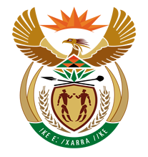

NATIONAL ASSEMBLY

QUESTION FOR WRITTEN REPLY

QUESTION NUMBER: 1377 [NW1519E]

DATE OF PUBLICATION: 26 MAY 2017

1377. Adv A de W Alberts (FF Plus) to ask the Minister of Finance: †
With reference to the collection of tax and value-added tax (VAT) by the SA Revenue Service (SARS), (a) what is the number of VAT refunds for the (i) five most recent tax years and (ii) current tax year that have not yet been made or that have in fact been made but were made late, and that were owed by SARS, (b) what is the number of VAT refunds, expressed as (i) a number and (ii) a percentage of the total, that have not yet been made or that were made late in each specified tax year, (c) what are the reasons for any refunds that were made late or were not made, and (d) what is the number of persons to whom VAT refunds were owed and audited by SARS, expressed as (i) a number and (ii) a percentage of the number, in relation to those persons to whom VAT refunds were not owed? NW1519E

REPLY:

(a)(i)(ii)(b)(i)(ii)(c)(d)(i)(ii)

The OTO announced earlier this year that they will be launching an investigation with regards to the refund processes administered by SARS to better understand the challenges, risks and complexity associated with the process. The investigation is currently underway and SARS is committed to working with the OTO to give them the required insight into the process so that they will be able to satisfactorily give feedback to the public on their findings.

SARS would want the current investigation underway to first be concluded before additional responses to the topic at hand is made as this stage.

